The relationship between science and religion:

The conflict model

This model of the relationship between science and religion assumes that there is a battle going on. Science and religion both make claims about the nature of the world and only one can be right. They are both fighting over the same ground and eventually one will be victorious and other will die out.

Scientists who support this model say that modern science can explain everything to do with the world and its origins and so religion is no longer required. For them, religion is a set of fairy-tales once used to explain certain things but now science can do that and so the fairy-tales can be abandoned. They don’t necessarily think religious people are bad, but they think that they are deluded and aren’t looking at the facts seriously.

Christians who support this model say that modern science has it all wrong. They would prefer to trust the version of events given by God over the human efforts of scientists. If the Bible says the earth was created in 6 days about 4,000 years ago then it must be so. They often dispute scientific theories, particularly evolution by natural selection, and may say that things like this are a test of faith. They believe that perhaps one day they might be proven right, but in the mean time it is their job to uphold their religious truth and show that science isn’t as reliable as it claims to be.

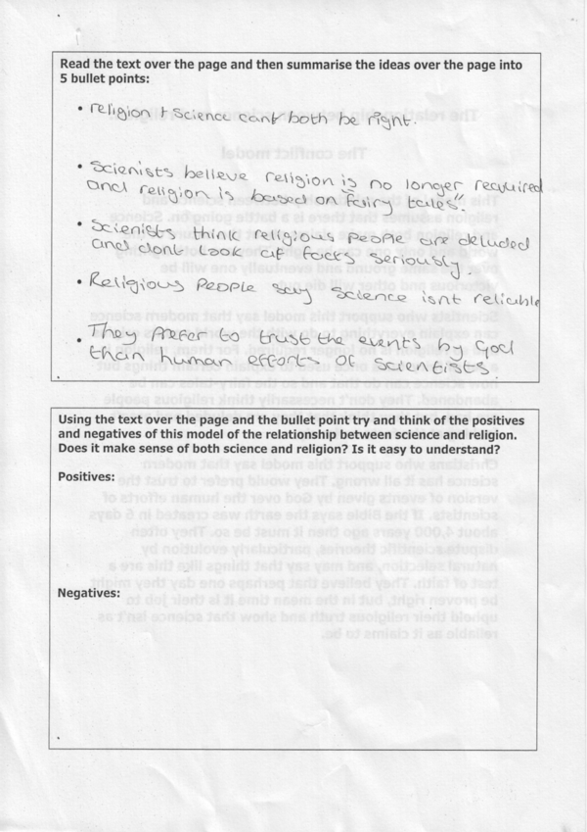
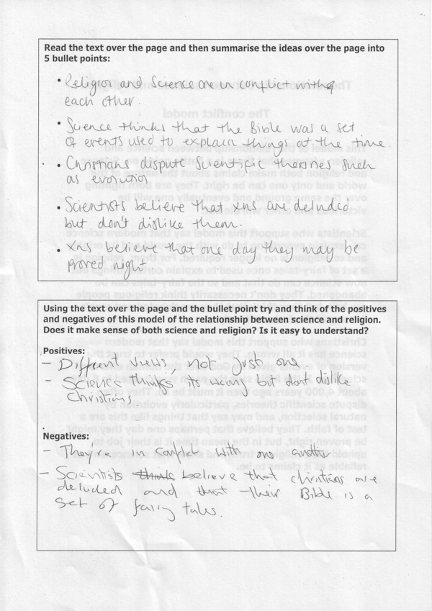

The ball represents the world and the knife represents the conflict between science and religion.

I’m not quite sure what this was supposed to represent any more…

