Christian Beliefs about the Soul

Christians believe that a person is not just made from his or her mind and body. Each person has an immortal soul; it cannot be seen, and it is that which makes humans different from animals. In the book of Genesis, in the Bible, it says: “So God created man in his own image.” There are different interpretations of this phrase, but many Christians think it means that God put something of his own divine and everlasting nature into each person and called it the ‘soul’. When God made animals in the creation story in Genesis, “he formed them out of dust”, but when he made Adam he also “breathed into his nostrils the breath of life and the man became a living being.”
Christians believe that animals do not have souls and therefore most are happy to eat meat. Christians believe that human life is very valuable to God because humans have souls.
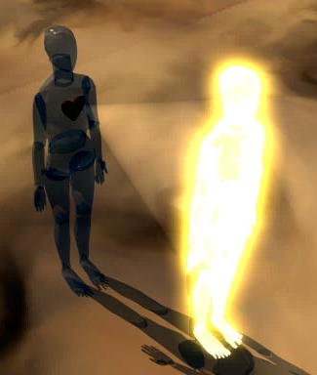
This biblical idea built on ideas from the Greek philosopher Plato, who said that people have souls which are separate from their bodies and do not die when the body dies. The soul cannot be seen, but it is something which makes each individual special and sacred (holy).
St Paul, one of the earliest Christian leaders, taught that the body and the soul are often in conflict. The soul wants to be with God and wants to do what is right, but sometimes the body prevents this from happening. The body is only interested in pleasures such as food and luxuries, and so the soul does not achieve its aims. St Paul also taught that the soul lives forever, whilst our imperfect bodies will die. Jesus’ resurrection was proof of this life after death: “If there is a natural body, there is also a spiritual body.” 1 Corinthians 15:44
Note down the key points from the text on your soul sheet. These sentence starters will point you in the right direction:
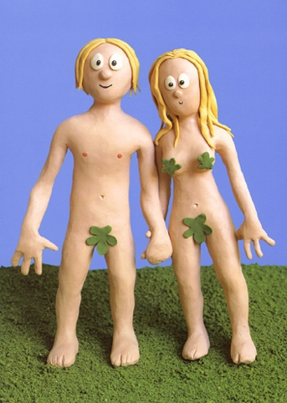
- Christians believe that humans are made up of 3 separate elements…
- The soul is…
- The soul makes humans different…
- The idea of the image of God is often believed to refer to…
- This is shown in human creation by…
- Plato, the Greek philosopher, believed…
- Paul taught that…
- Paul said Jesus’ resurrection…

Extension task:
What do you think about the soul?
- Does it exist?
- Is it immortal?
- Does it work in harmony with your body?
- How do body and soul interact (where is the soul)?
- How do your ideas compare with the Christian ideas of the soul?

