Suicide
Definition: Suicide is the act or an instance of killing oneself intentionally.
Read the following facts and underline the one, which you find most surprising.
- 19,000 people aged 15-24 attempt suicide each year in the UK; about 700 die
- Girls are more likely to attempt suicide than boys
- Boys are more likely to die from their suicide attempt
- Suicide rates in young men have doubled since 1985
Explain your choice:

Nearly everyone has times in their life when they feel sad and lonely. Sometimes it can feel as if no one really like us, that we are a failure, that we just upset people and that no one would care if we were dead. We may feel angry but unable to say so, or feel hopeless about the future. It is feelings life these that make some young people try to kill themselves. Often, several upsetting things have happened over a short time and one more upset or rejection is the last straw. Suicide is still taboo in today’s society and so suicidal feelings are difficult to talk about. Most people who attempt suicide will try to tell at least one other person of their intentions beforehand.

Why do people try
to commit suicide?

Christian Attitudes
Christians have always believed that all life is sacred and ultimately belongs to God. Therefore they believe that people have no right to kill themselves, any more than they have the right to kill others. In the past, the Church insisted that if you committed suicide you would not have eternal life. Today, however, the Church has a more compassionate attitude, accepting that people are under great pressure and often commit suicide when their minds are not stable. Christians try to work for a better community and society, believing that only a caring environment will help people to live happier and more fulfilled lives.
Bible: “Every man’s life is in His (God’s) power.” (Job 12:10)
“Love your neighbour as you love yourself.” (Mark12:31)
“I have the strength to face all conditions by the power that God gives me” (1 Cor 10:13)

How has the Church’s attitude towards suicide changed?

The Samaritans
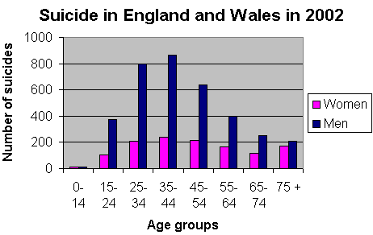
The Samaritans was founded by Chad Varah, a Church of England Vicar. In 1936 he conducted the funeral of a 14 year old girl; only a couple of people attended because the girl had committed suicide and this caused great shame. The girl had experienced her first period; unaware that this was perfectly normal, she was scared, convinced she had done something wrong to deserve this and she took her own life.
From this moment onwards, Chad Varah became increasingly concerned about the number of people who experienced such severe desperation. He installed a telephone in his Church and publicised the fact that anyone thinking of committing suicide should telephone him and talk to him. This was the start of the ‘Samaritans’. Today there are 185 centres and over 21,500 carefully selected and trained volunteers offering a 365-day 24-hour service.
- The main aim of the Samaritans is to be available at any hour of the day or night to befriend those passing through personal crises and in imminent danger of taking their own lives.
- The Samaritans aim to alleviate human misery, loneliness, despair and depression by listening to and befriending those who feel that they have no one else to turn to.
- The fact that a person has asked the help of The Samaritans is completely confidential.
- Experienced counsellors support Samaritan volunteers.
- Samaritans volunteers are forbidden to ‘preach’ if they are religious.

What are the qualities needed to
Be a Samaritan volunteer?

