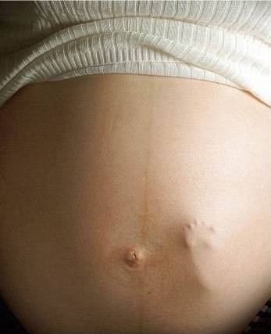
Abortion is the ending, or terminating, of a pregnancy before a baby is capable of surviving outside of its mother’s womb. It can happen naturally, this is known as miscarriage, or it can happen by inducement, when it is called an abortion or termination. In general, when people talk about an abortion, they are referring to the ending of a pregnancy by human intervention.
- Define abortion in your book.
Key issues for Christians on abortion:
The 6th of the 10 Commandments says, ‘Do not kill’; all Christians uphold this idea, whatever their denomination. However, there is dispute with abortion about when life begins and whether the taking of the life of an unborn child is therefore murder.
The Roman Catholic Church takes an absolute approach to abortion and teaches that all abortion is wrong and that a baby is a human from the time of conception. Evangelical and some other Protestant Churches agree.
Other Christians do not think the issue is so straightforward; they put forward other considerations, such as the life of the mother, the welfare of any other children she may already have, or her mental condition (for example if the pregnancy has resulted from rape or incest).
The main crux of the argument amongst Christians resolves around these issues:
- When does a baby become a human being with rights of its own that need to be protected?

When does a baby receive its soul and therefore become a full human being (in the image of God)?
There are two main responses to these questions:
- A person is a human being from conception; as soon as a sperm has fertilised an egg a new cell is formed that contains many of the characteristics of a person.
- The soul is the creation of God (the Bible tells of God giving Adam his soul), but when ensoulment takes place cannot be put to an exactly defined time. Ecclesiastes 12:7: “Our bodies will return to the dust of the earth, and the breath of life will go back to God, who gave it to us.” Many Christians would say that people derive their souls from their parents, as well as their bodies; the soul develops with the body.
- Explain why abortion is an ethical issue for Christians.
- What is meant by the term ‘ensoulment’?
- When do you think a baby becomes a human being with rights of their own?
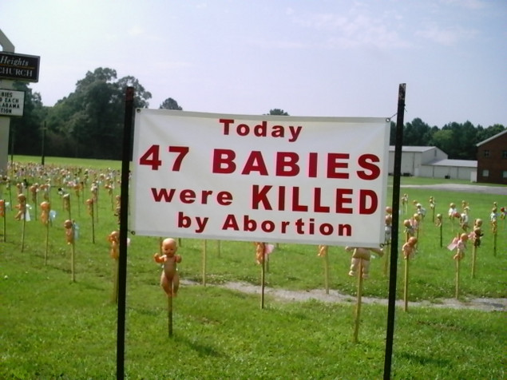
Alabama Church protests against abortion use baby dolls on stakes to evoke an emotional response to the issue.
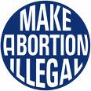 | 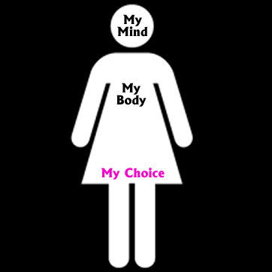 | 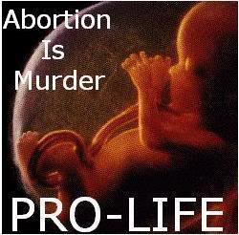 | 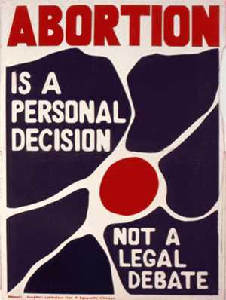
When is Abortion Legal in Britain?
Before 1968 abortion was illegal in Britain. Since the 1967 Abortion Act (which became law in 1968) abortion has been legal if:
- Two doctors agree that it is needed
- It is carried out on a registered premises
- The baby is not yet capable of surviving; the term for this is ‘viable’: “able to survive apart from the mother if born and cared for medically”
In deciding if an abortion is needed, doctors must consider whether:
- The life, health or mental health of the mother is at risk
- An existing family will suffer if the pregnancy continues
- There is a reasonable chance that the child will be born handicapped
In 1968 the latest termination date in cases of risk to the mother’s mental health or an existing family was set at 28 weeks. In 1990 this was reduced to 24 weeks as improvements in special care units meant babies were ‘viable’ from a younger stage of development. There is now no time limit in cases of risk to the mother’s life or where there is a risk of the baby being handicapped.
The 1967 Act was introduced by David Steel, a Christian MP, on the grounds that every year around 30 women died from illegal abortions and that, in some situations, abortion was the ‘lesser of two evils.’
The number of abortions has risen steadily; in practice ‘the mental health of the mother’ has been interpreted to include the distress that the mother might feel regarding pregnancy or motherhood. Some people say that there is effectively ‘abortion on demand.’ Some would go so far as to say that abortion is now treated as a form of contraception.
The law allows medical staff to abstain from performing abortions, but there have been cases of people finding their jobs at risk when trying to opt out of abortions.
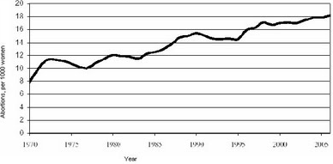
The UK abortion rate: 1975-2006
In 1968 there were 5.3 abortions for each 1000 women; by 2006 this had reached 18.2 abortions (a third of these women had already had a previous abortion). 22% of pregnancies in the UK end in abortion; this does not take into account the morning after pill, so the actual rate could be higher.
- Summarise the legal position on abortion in Britain.
- Why did David Steel refer to abortion as the ‘lesser of two evils’?
- How do you account for the number of abortions having risen so sharply?
- Why do some people say we have ‘abortion on demand’ in Britain?
Christian Viewponts:
When does life begin?
Christian attitudes towards abortion vary widely, and the teachings of Christian churches has changed over the centuries. In the first 200 years after the beginning of Christianity, abortion was common, and so was the practice of killing young babies (infanticide) if they were unwanted or their parents could not afford to bring them up. The debate as to whether this was acceptable to Christians focused on ‘ensoulment’; if a foetus did not have a soul, abortion could be acceptable as this did not count as murder. The early conclusion was that the soul was given at 40 days, if the foetus was a boy and at 80 days if it was a girl, so abortion was allowed in the very early stages of pregnancy, but not later. Infanticide was not allowed at all.
Over the following centuries Christians consistently opposed abortion and this remained the attitude of most Christians until the 1960s. Today, among and within the different Christian churches there are differing viewpoints, but all Churches share the view of the sanctity and mystery of life and condemn the growing practice in many countries of abortion on the grounds of convenience.
The Roman Catholic Viewpoint: Pro-life or anti-abortion
The Roman Catholic Church is the only Christian church to give an absolute teaching on abortion; abortion is never allowed, even if the pregnancy is the result of a rape or if the pregnant woman is very young. The only circumstance in which abortion is absolutely necessary is in order to save the life of the mother (as she is the established life).
Pro-life arguments:
- The embryo or foetus is the beginning of human life and life is a gift from God
- Life should never be deliberately destroyed
- Abortion should never be used as a method of contraception, indeed, some methods of birth control are agents of abortion
“Human life is sacred. All men must recognise the fact.” Pope Paul VI, 1968.
Other Christians from different traditions might agree with this view and believe that abortion is always wrong. They might feel that abortion treats human life too cheaply; it should be viewed as sacred even before birth. Biblical ideas can be used to support this view and suggest that abortion interferes with God’s plans for each person.
‘Before I formed you in the womb I knew you. Before you were born I set you apart; I appointed you as a prophet to the nations.’ (Jeremiah 1:5)
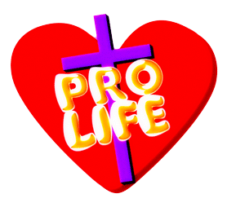
The Church of England view: pro-choice; not pro-abortion
The Church of England is against abortion in principle, but also accepts that each case is special. Whilst it should not be generally acceptable (certainly not as a method of birth control or for convenience reasons), it may be permitted in some cases, for example:
- If there is a risk to the woman’s life
- If conception results from rape
- If there is a risk the baby will be handicapped
“Christians need to face the fact that, in an imperfect world, the ‘right’ choice is sometimes the acceptance of the lesser of two evils.” Church of England Board for Social Responsibility, 1990.
Some Christians believe that the most important Biblical reference to use to give guidance on abortion is the Golden Rule stated by Jesus:
‘So in everything, do to others what you would have them do to you, for this sums up the Law and the Prophets.’ Matthew 7:12
This suggests that Christians should try to put into practice the principle of agape (unconditional love) and try to imagine what they would want faced with the same situation. They might come to the conclusion that, in some circumstances, abortion could be the kindest and most loving solution to the situation.
Pro-choice arguments:
- The Bible teaches compassion for the weak. Abortion could be argued as the most loving thing in many cases (an unsupported, single mother)
- Jesus suggested people should live a full life. Abortion can save pain and distress for all concerned with the life of a severely brain-damage foetus
- God created humans with free-will. Legal abortions give people the freedom to choose their path in life
Being pro-choice does not mean being pro-abortion. Many pro-choice Christians would see abortion as a last resort if no alternative could be found (such as adoption); they tolerate abortion rather than favouring it.
- How have Christian views on abortion developed over time?
- Explain the Roman Catholic view on abortion with use of relevant quotations.
- Explain the Church of England view on abortion with use of relevant quotations.
- What is the difference between being pro-choice and pro-abortion?
INCLUDEPICTURE "http://www.stltoday.com/blogzone/civil-religion/files/2009/03/pro-child-pro-choice.jpg" \* MERGEFORMAT 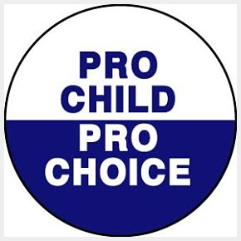 INCLUDEPICTURE "http://www.stltoday.com/blogzone/civil-religion/files/2009/03/pro-child-pro-choice.jpg" \* MERGEFORMAT

