
CVC Mathematics
Department
Year 10
HomeworkName:ScoreSmall Group
Teacher:Due Date:
Thursday, 6th Oct 2012%

Target:
You will need a calculator, pencil and ruler to complete this homework. You are reminded to always show your methods.

Revision

1. A bag contains some sweets. The flavours of the sweets are either strawberry or chocolate or mint or orange.  Sarah is going to take one sweet at random from the bag.  The table shows the probability that Sarah will take a strawberry sweet or a mint sweet or an orange sweet.  Work out the probability that Sarah will take a chocolate sweet.  .............................(2 marks) |  | 2. Sanjay prepares a questionnaire. Here is one of his questions.  What is wrong with this question?  .........................................................................................  .................................................................................................................................................................... (1 mark)
  Flavour | Probability
  Strawberry | 0.32
  Chocolate
  Mint | 0.17
  Orange | 0.2
  What is your age in years?
  under 20
  20 – 30
  30 – 40
  40 – 50
  over 50
3. 80 people work in Joe’s factory. The table shows some information about the annual pay of these 80 workers.

Annual pay (£x) | Number of workers
10 000 < x ≤ 14 000 | 32
14 000 < x ≤ 16 000 | 24
16 000 < x ≤ 18 000 | 16
18 000 < x ≤ 20 000 | 6
20 000 < x ≤ 40 000 | 2

(a) Write down the modal class interval.
..............................................(1 mark)
(b) Find the class interval that contains the median.
……….................................. (1 mark)
(c) Calculate an estimate for the mean annual pay.

……….................................. (4 marks)
4. The mean of 6 numbers is 12.3. When an extra number is added, the mean changes to 11.9. What is the extra number?  …………………………………. (3 marks) | 5. State the type of correlations each of these scatter graph show:  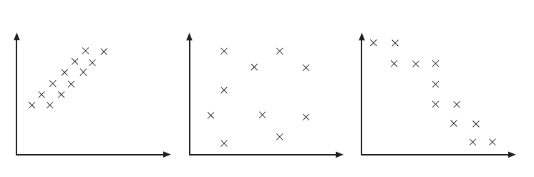  ……………………… …………………….. ………………………  (3 marks)
Cumulative frequency and box plots

6. The cumulative frequency table gives information about the number of minutes 80 customers were in a supermarket.
100
90
80
70
60
50
40
30
20
10
0
0
10
70
60
50
40
30
20
Number of minutes (t) in a supermarket
Cumulative frequency

Number of minutes (t)  in a supermarket | Frequency | Cumulative  frequency | Co-ordiantes
0 < t ≤ 10 | 2
10 < t ≤ 20 | 6
20 < t ≤ 30 | 10
30 < t ≤ 40 | 22
40 < t ≤ 50 | 24
50 < t ≤ 60 | 13
60 < t ≤ 70 | 3

(a) On the grid opposite, draw a cumulative frequency graph for the data in the table.
(4 marks)
(b)Use your cumulative frequency graph to work out an estimate for the inter quartile range of the number of minutes customers were in the supermarket.

……………………… minutes (3 marks)
7. The cumulative frequency graph shows some information about the numbers of goals scored by 160 players from country A.
(a) Use this graph to find an estimate for
the median ....................... goals
the lower quartile ....................... goals
the upper quartile ........................ goals
(3 marks)
The lowest number of goals scored was 0
The highest number of goals scored was 32

(b) On the grid, draw a box plot to show information about the numbers of goals scored by players in country A.
(3 marks)
Country A:

(c) Write two comparisons of players from country A and B
(i)…………………………………………………………………………………………………………………………………………………………………(ii).…………………………………………………………………………………………………………………………………………………...(2 marks)
(d) Estimate the percentage of players, from country A, that scored more than 25 goals.

…………………….(3 marks)

Country B:

www.mymaths.co.uk School Login: School Password:
My Login:……………………. My Password:……………..
Complete the online lesson and homework for: Data -> Cumulative frequency -> Cumulative frequency
Data -> Cumulative frequency -> Box and whisker plots
Don’t forget to “Mark it” when you have completed the questions and “Check out” to save your results!

