


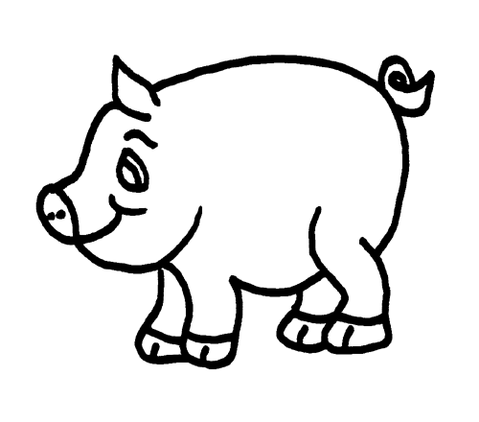
Christian attitudes to animals and their treatment
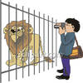
Many people have ethical objections to treating animals cruelly, but there are a range of lines that can be drawn when thinking what cruelty is and to what extent it can be justified. Some people feel it’s cruel to keep animals as pets or in zoos, whereas other people believe these both have important parts to play in the relationship between humans and animals and also in preserving endangered species through breeding programmes.
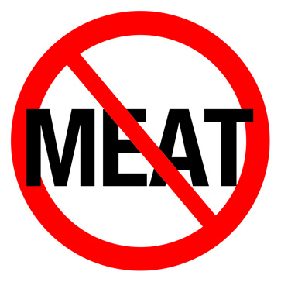
Some people feel that humans should not eat animals because of the cruelty involved in raising and killing them. Some Christians argue that humans were originally designed as vegetarian because of the following Bible passages:
Initially God said:
‘Then God said, ‘I give you every seed-bearing plant on the face of the whole earth and every tree that has fruit with seed in it. They will be yours for food’.’: Genesis 1:29
Later God said:
‘Everything that lives and moves will be food for you. Just as I gave you the green plants, I now give you everything.’: Genesis 9:3
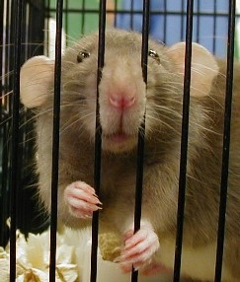
Some people feel it can never be justified to test on animals during scientific research, whereas others believe this provides important benefits to humans that outweigh the suffering. You have looked at this in great detail in Medical Ethics.
Humans should be responsible stewards. Humans were told to ‘rule over’ the animals, but there is also a role in taking care of the animals. Many church denominations have released statements to this effect.

‘The universe as a whole is a product of God’s creative and imaginative will. Men and women are to be stewards and curators not exploiters of its resources: material, animal and spiritual.’: Methodist Church
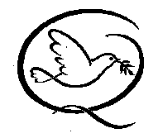
‘[We] believe that the air, sea, earth, forests, animals and ourselves are all intimately connected, and the way in which we treat all of those things reflects on ourselves and consequently on God’: Quakers

