How do places of worship tell us about the religions they represent?

Your task:
Your job is to write an essay that explores different religious places of worship. Every religion has a place they go to in order to worship. These places aren’t just buildings; they represent different things about what the religion believes.
You need to write something that tells me about these different places of worship. It needs to explain what these places look like, what they have in them, what people do in them, and most importantly why. Don’t be satisfied with just saying what but say why! If you don’t know why, then try to find out!

Resources:
There are loads of books in the class room. This will be a good place to start. You can also look at my blog (www.mdbigg.me.uk/cvc) where there are loads of links.
I suggest that you look at two or three different places of worship for comparison:
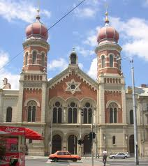
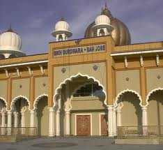
- Christian Church
- Muslim Mosque
- Sikh Gurdwara
- Hindu Mandir
- Jewish Synagogue
- Buddhist Temple

Levels:

Level 5: Explanation
To get Level 5 you need to explain something about two or three places of worship. What’s in the place of worship and what does this tell us about the religion?

Level 6: Analysis
For Level 6 it is essential that you analyse. You need to compare the similarities and differences between different places of worship. What do these tell us about the religions?

Level 7: Evaluation
“Which place of worship most fully reflects its religion?” – For level 7 you need to come to a conclusion about this question. Look at two or three different places of worship: which one tells us most about the beliefs of the religion itself and why?

