
Year 9 Assessment:
How should people make their ethical decisions?

This assessment summarises everything we’ve done this year on ethics. It asks questions about what we should do when we have to decide about what is the right thing to do.

Your task is to write an essay explaining the different systems people can use to make decisions about right and wrong. You could discuss:


- Utilitarianism: The most happiness for the most people
- Religious Ethics: Taking right and wrong from religious principles
- Situation Ethics: Looking for the most loving thing to do in any situation
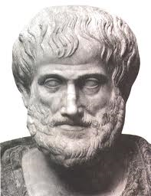
- Virtue Ethics: Assuming that good, brave, kind, loving people will make good, brave, kind, loving decisions
- Ego-centric Ethics: Working out the best thing for me

Your essay should consider at least 3 of these in order to come to a conclusion
about the best way to make decisions about right and wrong.

Suggested Structure:
- Introduction: What is ethical decision making? Explain what the question is asking.
- Explain the systems: Take a few paragraphs to explain a couple of the principles people have used to make ethical decisions. Eg. What is Utilitarianism? Situation Ethics? You are encouraged to use Mr Bigg’s blog and the internet to find out more detail.
- Examples: Explain how the ethical systems might be used in different circumstances. For example, how might the different systems be used to tackle the issue of abortion? Or what would they say about whether it is ever right to steal?
- Analysis: If you want to get Level 6 you need this paragraph. What are the good/bad points about the different systems? Is bringing the greatest happiness to the most people a good basis on which to make ethical decisions? What might the problems be? Think about the pros and cons of each different system.
- Conclusion: Which is the best system for making ethical decisions? Why is the system you have chosen better than the other systems? A good conclusion is required for level 7.

Levels:
- Level 4 – Description: Here you are just telling me a bit about the different ethical systems.
- Level 5 – Explanation: You are starting to give detail about how they might be used. This particularly comes in section 3 when you explain how the different ideas apply in different situations.
- Level 6 – Analysis: In section 4 you are starting to analyse in considering the good and bad points about the different ways of making decisions.
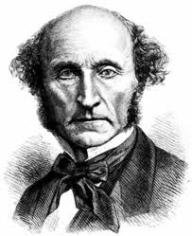
- Level 7 – Evaluation: To get this you need a strong conclusion (section 5). You are explaining why one system for making ethical decisions is better than others and giving convincing reasons. You need to show you have thought about the different ways of doing things and why some ways may be better than others.

Good luck! This is a challenging task but there is lots of scope for doing really well!

