Key words:
War Armed conflict between nations or parties within a nation
Persecution Campaign to harm a particular group in society
Peace Mutual harmony between people or groups
Violence Rough or injurious physical treatment
Pacifism Opposition to war or violence of any kind
Conscientious Objectors Refusal to fight because of one's principles or beliefs
Protection Defend from harm
Reformation Improve what is wrong or corrupt
Deterrence Discourage from acting in a certain way
Retribution Proportional punishment in response to an action
Forgiveness To stop feeling resentment towards someone
Social Injustice Members of society have fewer rights and privileges than others
Liberation Freedom from controlling or restricting conditions

Course content:
- Can war ever be justified?
- Should Christians be pacifists?
- How should criminals be punished?
- How should Christians respond to social injustice?

1 Christian attitudes towards war: the Just War
Generally Christians believe that war is wrong and that God wants everyone to live in peace. Early Christians took Jesus’ teachings on non-violence very seriously and were pacifists; they refused to serve in Roman armies. However, when the stability of the Roman Empire was threatened, Christians began to argue that there might be times when they could be justified in waging war, but only if certain conditions were met. This position came to be called the ‘just war’.
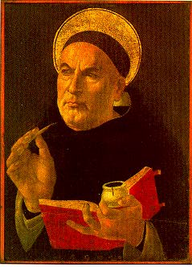
There is no one teaching on war in the Bible; Christians have to decide whether fighting can be justified in each situation.
Opinion 1: most Christians would say that war is sometimes necessary to overcome evil.
For example: self-defence, to overthrow a dictator, to help out those in need. They might follow just war theory, which says a war can only be fought if certain conditions are met. These conditions are designed to prevent war happening and to limit its effects if it does take place. The ideas were developed by St Thomas Aquinas (1225-1274) and built on by Francisco de Vitoria (1483-1546) and are still used by Christians today.
Authority  A | Started by a legal authority: government or monarch
Cause  C | Just cause to fight
Outcome  O | There will be a good outcome from the war
Last resort  L | All else has been tried and has failed
Force  F | Limited force must be used: proportional to the fight
Success  S | Good chance of winning the war
Just War Theory: ACOLFS
A Bible quote to back up this view would be…
An eye for an eye, a tooth for a tooth.

Opinion 2: some Christians think war is never acceptable under any circumstances; an example of this would be Quakers. People who oppose violence are called pacifists and in times of war, they would be ‘conscientious objectors’ (their consciences tell them to object to war). In war they would:
- Refuse to fight as soldiers
- Refuse to work in arms production
- Support the war effort in peaceful ways, such as nursing
A Bible quote to back up this view would be…
Love your enemies and pray for those who persecute you.

2 Christian attitudes towards the use of violence and towards pacifism
The Bible offers different views as to whether violence (not just war) can ever be acceptable.
Opinion 1: many Christians would agree that sometimes violence is unavoidable, for example in self defence. The Old Testament has many stories of people being told to go to war. Although one of the 10 commandments says ‘Do not kill’; many people think this is not the same as killing during war.
Opinion 2: some Christians think that it is never right to retaliate with violence, even when other people are aggressive. Such people are pacifists and would deal with all conflict non-violently; this is because of the Christian principle of agape: unconditional love for all people. Non-violent methods of dealing with disagreements could include trade sanctions, negotiations, and mutual agreements; none of these cost lives. In times of war, pacifists would be conscientious objectors; Quakers hold these views and say: “We utterly deny all outward wars and strife and fightings with outward weapons, for any end, or under any pretence whatever.”
A Bible quote to back up this view would be…
‘Nation will not take up sword against nation, nor will they train for war any more.’
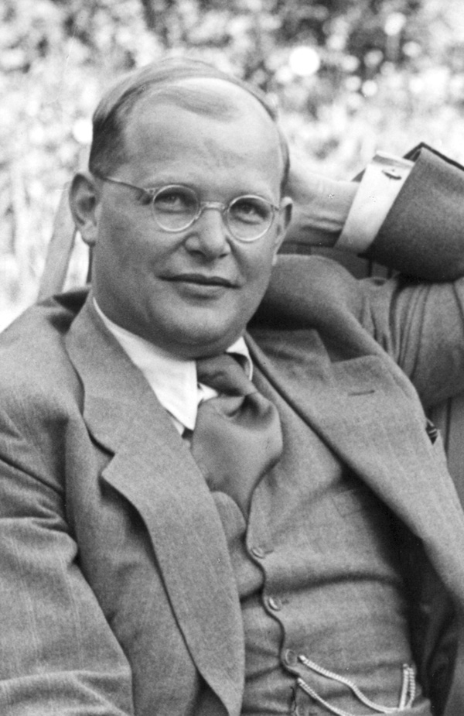
Dietrich Bonhoeffer (1906-1945)
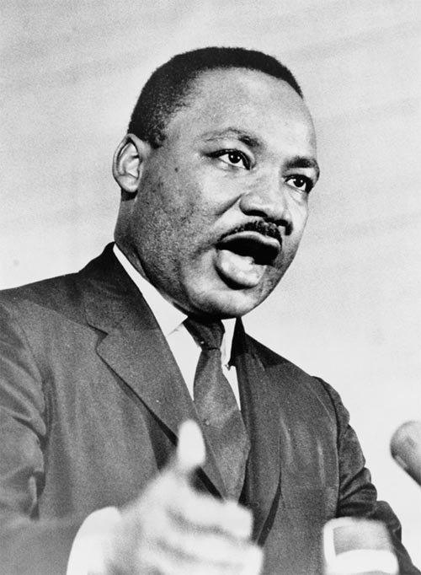
The German Theologian Bonhoeffer started life as a pacifist, but came to believe that there are times when the result of non-violence will be much worse than fighting; he felt that pacifism could not work against people such as the Nazis. He plotted to over-throw the Nazi party and was prepared to take part in an assassination attempt on Adolf Hitler. Although he was a pacifist and opposed to any form of violence, he was prepared to sacrifice not only himself, but also his principles to try to rid the world of the evils of Nazism. When the assassination plot against Hitler failed, Bonhoeffer was arrested and executed.
Martin Luther King
Martin Luther King was hugely influenced by his father (a Baptist minister) and Gandhi (a Hindu pacifist). His Christian beliefs on agape (unconditional love for one’s neighbour) led him to fight racial oppression in America through non-violent means. He taught people to ‘Meet violence with non-violence; hate with love’, and to ‘Hate the system, rather than the individual; love the person, not the evil deed’. His high profile demonstrations, speeches, boycotts, sit ins, and marches led to equal rights for black people.
Non-violent methods:
D Demonstrations
A Advertisements
M Marches
S Speeches / sit-ins

3 Christian beliefs about the treatment of criminals
Christianity teaches a message of forgiveness and of love for enemies. This could appear to mean that Christians should not punish criminals, but forgive them instead; however, Christians think it’s important for society to have law and order to function properly. There is a story in John’s Gospel of a woman who is about to be stoned to death; Jesus says, “let he who is without sin cast the first stone” and one by one they went away. The message is to ensure that people judge fairly and look to their own faults as well as those of others.
Protection  P | 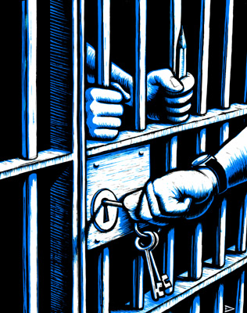 | The punishment allows society to be protected from somebody’s anti-social behaviour
Reform  R | 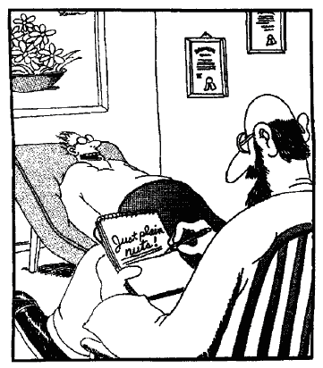 | The punishment helps the offender to become a responsible member of society
Deterrence  D | 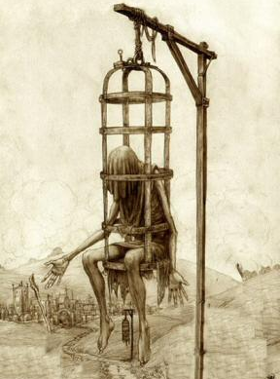 | The punishment puts the criminal and the rest of society off committing crime again
Retribution  R | 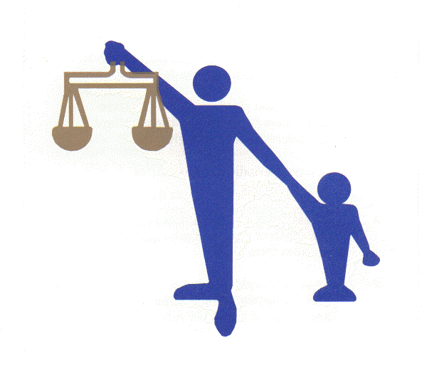 | The punishment is fitting ‘pay back’ for the crime that has been committed
Vindication  V | 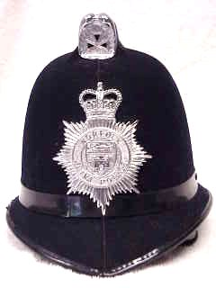 | Punishing criminals means the law is upheld and respected by society
PRDRV: Police rarely deter ruffians violently
Capital Punishment
Some Christians say capital punishment is acceptable as a deterrent.
An eye for an eye, a tooth for a tooth
Other Christians say capital punishment is never acceptable; reform is more important.
Arguments for and against capital punishment:
For | Against
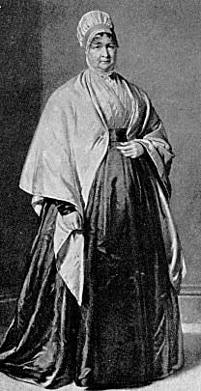
Some Christians have campaigned for better conditions for prisoners:
Elizabeth Fry
      - Quaker beliefs
      - Suggested need for rights for prisoners
      - Introduced privacy for prisoners
      - Promoted the need to teach prisoners a trade
      - Her ideas still influential today

The Howard League for Penal Reform
They put pressure on the Government to improve prison conditions. This is not a Christian organisation, but does have Christian members.
Their mission statement:
“The Howard League works for humane and rational reform of the penal system. We research and comment on criminal justice policy and practice, holding conferences and debates, publishing books and reports. We also run projects in schools and prisons.”

4 Christian responses to social injustice
Social injustice - This is the term used to refer to occasions when members of society have fewer rights and privileges than others. Christians believe that all people are equally valuable to God, therefore any form of injustice is always wrong
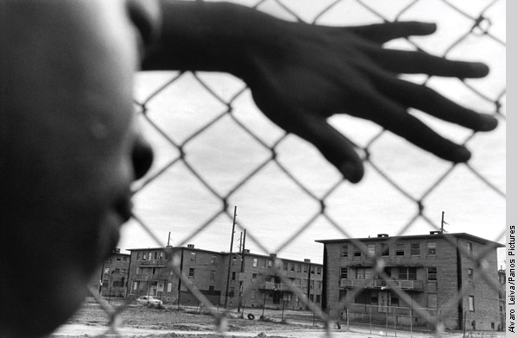
Christians believe that all people are equally valuable to God and, therefore, they believe that any form of injustice is always wrong. Christians do not always live up to the standards set for them, but at least in principle, they do all they can to make the world a fairer place for those who live in it.

What the Bible says:
- The Bible teaches that it is wrong to mistreat the poor and the weak
- In the Old Testament, the prophets spoke out against social injustice, telling people God saw what they were doing and would punish them, unless they changed their ways
- In the New Testament, Christians are warned against ignoring the poor
“If you show special attention to the man wearing fine clothes and say, ‘Here’s a good seat for you,’ but say to the poor man, ‘You stand there’, or ‘Sit by my feet,’ have you not discriminated among yourselves and become judges with evil thoughts?” James 2:2-4
Christian beliefs into action:
The Bible also teaches that people from ethnic minorities and immigrants (often called ‘aliens’ in the Bible) should be treated the same as relatives, welcomed and given equal chances of employment. Because of these beliefs some Christians have devoted their lives to fighting against racism, for social inclusion, for rights for the disabled (e.g. in MENCAP), for rights for prisoners (e.g. The Howard League for Penal Reform) and to help people around the world (e.g. Christian Aid).
“For I was hungry and you gave me something to eat, I was thirsty and you gave me something to drink, I was a stranger and you invited me in, I needed clothes and you clothed me, I was sick and you looked after me, I was in prison and you came to visit me.” Matthew 25:35-36

Liberation Theology
- Began in 1960s Central and South America; mainly within the Roman Catholic Church
- Believes Christians have a duty to fight against poverty, oppression and injustice
- In countries, such as El Salvador, government corruption meant that a few people were very rich, while the rest were very poor
- Those who protested were often arrested, held without trial, tortured, or disappeared
The relationship between religion and politics:
Opinion 1: it is not the place of religion to get involved in politics; leave politics to the politicians and focus on serving God personally
“Therefore render to Caesar the things that are Caesar's, and to God the things that are God's.” Matthew 22: 21

What should people do instead?
- Help people
- Charity work
Opinion 2: other people, for example liberation theologians, argue a Christian should actively challenge injustice – love your neighbour means help your neighbour
Oscar Romero
Oscar Romero was a Roman Catholic priest who lived in El Salvador in the 1970’s. The country was ruled by a few rich men, whilst most people lived in poverty. In keeping control, the rich families murdered, tortured and kidnapped hundreds of people every month. Romero was made Archbishop in 1977 and a few weeks later his friend (Father Rutilio Grande) was murdered for speaking out for the poor and oppressed. Romero spoke out against the government publically; he said violence could be overcome by Christian love. His work angered some Church leaders who complained to the Pope that he was causing political unrest, but to the people of El Salvador, he was a hero willing to speak out against corrupt governments and human rights abuses.
He was shot dead whilst celebrating mass; his last words were: “May God have mercy on the assassin.” Over 250,000 people from all over the world attended his funeral, but this turned to violence when soldiers opened fire on the crowds and killed 40 people.
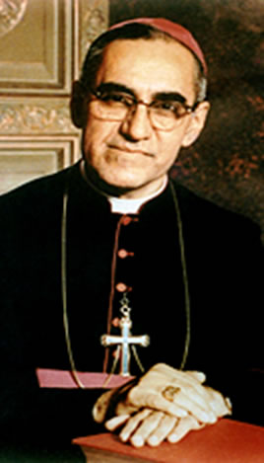
"I do not believe in death without resurrection. If they kill me, I will be resurrected in the hearts of the Salvadoran people." Oscar Romero

Amnesty International
Amnesty International is an organisation that campaigns for human rights, and many of its members are Christians. It began in 1961, when Peter Benenson, a British lawyer, read about some students who had been sent to prison unfairly.
Their mission statement:
“To free all prisoners of conscience; ensure fair and prompt trials for political prisoners; abolish the death penalty, torture and other cruel treatment of prisoners; end political killings and “disappearances”; and oppose human rights abuses by opposition groups.’
- Prisoners of conscience are people who are in prison because of their beliefs, whether or not they have committed any crime.
- Amnesty works by setting up letter-writing and publicity campaigns as well as protests so people are made aware of particular human rights abuses. Many countries who practice abuses do not wish the rest of the world to know what is going on and so may stop if they are exposed.
- Amnesty has over a million members in more than 160 countries in the world.

Why do Christians think social injustice is wrong?
Why do some Christians feel it is wrong to get involved with politics?
Was Oscar Romero right to speak out against the government of El Salvador?

