Key words:
Sacred Entitled to religious respect by association with the divine
Precious Highly esteemed for a spiritual quality
Abortion The removal of an unborn child from the uterus to end a pregnancy
Ensoulment The point at which an unborn child receives its soul
Pro-Life Human life should be valued from conception to natural death
Pro-Choice Women should have the choice about when it is acceptable to end life
Euthanasia The act of putting to death painlessly or allowing to die
Suicide Intentionally taking one’s own life
Hospice A place where the terminally ill are offered palliative care before death

Course content:
- What do Christians believe about the issue of abortion?
- How do Christians respond to IVF and cloning?
- What are the key beliefs about euthanasia and suicide in Christianity?
- Is it ever right to use animals in medical research?

Sanctity of life
Many religious people have strong opinions about medical ethics because they deal with matters of life and death. Christianity teaches that every person is made in the image of God, that all life comes from God, and that life is ‘sacred’ or holy. When people are talking about the way in which human life is special to God, they use the phrase the sanctity of life.
- Life is given by God
- All life deserves respect
- Human life is precious, like the temple of God
- Life should not be destroyed
- God has a plan for every human life.
 | “Are not five sparrows sold for two pennies? Yet not one sparrow is forgotten by God… Do not be afraid you are worth more than many sparrows.”: Luke 12:6-7
“So God created human beings, making them to be like himself.”: Genesis 1:27 |  | “Do not commit murder”: Exodus 20:13 | “Surely you know that you are God’s temple and that God’s spirit lives in you. So if anyone destroys God’s temple, God will destroy him.”: 1 Corinthians 3:16-17
 | “You created every part of me; you put together in my mother’s womb… when I was growing there in secret you knew that I was there.”: Psalm 139:13-16
1 Different Christian attitudes towards abortion
An abortion is when a foetus is expelled from its mother’s uterus and dies before it is ready to be born. This can happen naturally and is called a miscarriage.
Why might someone decide to have an abortion?
Too young Rape Incest Poor relationship
Lack of money Career Handicap Lifestyle choice
Physical health Mental health Family pressure Effect on other children
The Law:
Abortion has been legal in this country since the 1967 Abortion Act; it was originally set at 28 weeks and saw the number of ‘backstreet abortions’ reduce. In 1990, the limit was reduced to 24 weeks because of improved post-natal care and viability. A woman needs two doctors to consent to the procedure on the grounds that her mental and physical health is at risk; the decision should be taken as early as possible. Abortion is only legal in the first 24 weeks of a pregnancy; however, if there is a risk to the mother’s health or a chance of handicap then it is possible to have an abortion until full term.
The Church:
The key issues:
- When does life begin (ensoulment)?
- Is abortion murder?
- Are there genuine reasons for abortion?
- What rights does an unborn child have?
All Christians would agree that life is a gift from God and should be cherished, which means that ‘abortion on demand’ (for lifestyle reasons) is unacceptable. Christians disagree over whether there are some circumstances when abortion could be seen as the ‘lesser of two evils’.
The Roman Catholic View:
The Catholic Church is pro-life and takes an absolute view; abortion is never acceptable, even if the pregnancy is the result of rape or if the mother is very young. The only circumstance in which abortion is allowed, is if the life of the mother is in danger; the purpose of the operation in such a case is to save an established life, not to destroy one. This is known as the Doctrine of Double Effect. Catholics base this view on their belief that a foetus is a person with a soul from the moment of conception and destroying a sacred, God-given life can never be acceptable.
Before I formed you in the womb I knew you, before you were born I set you apart... Jeremiah 1:5
Roman Catholic beliefs in action:
- Counsel the mother against abortion
- Support the mother through the pregnancy
- Suggest adoption as an alternative to abortion
The Church of England View:
The Church of England takes a situational view; they believe abortion is wrong in principle, but see each case as special. They argue that Christians should put the principle of agape (unconditional love) into action and try to imagine what they would want if faced with the same situation. Abortion should not be generally acceptable (and certainly not as a method of birth control), but in certain circumstances it could be seen as the more loving and kindest solution to the situation.
- There is a risk to the life of the mother
- Conception is the result of rape
- The baby will be born handicapped
So in everything, do to others what you would have them do to you…
Matthew 7:12
Pro-choice arguments:
- Suggest alternatives to abortion such as adoption
- Support decision in some cases as ‘the lesser of two evils’
- Offer pre and post abortion counselling and support

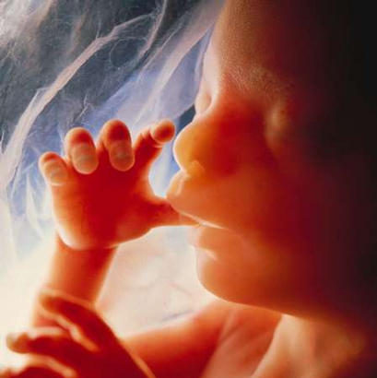
In Summary…
- Legal since 1967
- Term reduced from 28 to 24 weeks of pregnancy
- Debate about ‘ensoulment’
- All Christians against abortion for convenience
- RC: against all abortion except when mother’s life at risk
- CofE: against abortion in principle, but sometimes accept it as ‘lesser of two evils’

2 Christian responses to issues raised by fertility treatment
Fertility treatments are medical treatments given to couples when they are unable to conceive naturally after trying for 12-18 months.
Why couples might be infertile
Man does not produce healthy sperm Woman does not ovulate
Illness such as cancer treatments Blocked fallopian tubes
Woman cannot carry a child Impotence
Definitions:
AIH: Artificial Insemination by Husband – the husband’s sperm is used to impregnate the woman
AID: Artificial Insemination by Donor – the sperm of an anonymous donor is used to impregnate the woman
IVF: In Vitro Fertilisation – an egg is withdrawn from the woman and fertilised (husband’s or donor’s sperm) in a laboratory; healthy embryos are then placed into the womb
Egg donation A donated egg is fertilised and placed in another woman’s uterus
Embryo donation A donated egg is fertilised by donated sperm and the embryo is placed into the woman
Surrogacy A woman carries a child for another woman who cannot become pregnant; she hands over the child at birth. The birth mother is legally the baby’s mother (it is illegal in this country to pay a woman to do this).
How many people could be involved with each of these treatments?
1 | 2 | 3 | 4 | 5

The Church:
The key issues:
- The Bible is too old for any direct teachings on this contemporary issue (the first test tube baby was born in 1978)
- Procreation is a part of marriage and infertility can put a strain on a couple
- Fertility treatments go against God’s intentions; they are unnatural
- Fertility treatments generate spare embryos, which might need to be disposed
- Donors introduce third parties into relationships meant for two people
- In the Old Testament, children are viewed as a reward for goodness; fertility is God’s decision
‘Hannah had no children… because the Lord had closed her womb’ 1 Samuel 1: 26
The Roman Catholic View:
Roman Catholics believe that life comes from God; no-one has the right to children. They would sympathise with a childless couple, but believe that children should be created in the natural way through sexual intercourse. Fertility treatments are banned for the following reasons:
  - God intended procreation (creating children) to happen through sexual intercourse
  - IVF usually leaves spare embryos that will be disposed; this is like abortion
  - All forms of artificial insemination involve masturbation, which is a sin for Catholics
  - Children have the right to know who their parents are
The Church of England View:
The Church of England view is largely influenced by the golden rule: “love the Lord your God with all your heart and with all your soul... Love your neighbour as yourself.” (Mark 12). In certain situations it may be the most loving action to use the gifts of healing that God has given in order to create a child for a loving couple. Intercourse and procreation are separate things and so couples can be helped to have children. They allow IVF and AIH because:
- Procreation is a purpose of marriage so helping a couple to produce a family is good
- The egg and the sperm are from the husband and wife so there are no third parties; just technology
- Any discarded embryos are not foetuses and not living beings
There will be differences of opinion over whether it is right to use donors because it introduces a third person to the marriage and because of the potential confusion for the identity of the child. There are also legal implications with using donors and surrogates.
Cloning:
Advantages:  Cure diseases / organ donations / improve farming / reverse ageing / protect species | Disadvantages:  Unnatural / underlying problems with clones / difficult to do / inherits problems of parent / devalue human life
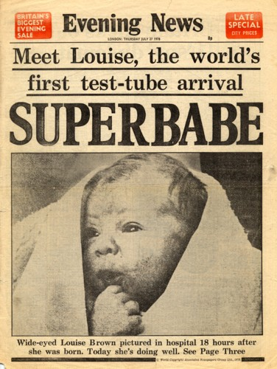
In Summary…
- There are a variety of treatments to help infertile couples
- RC against all treatments as God decides when a baby should be born and disposing of spare embryos, masturbation, and uncertain parenthood are sinful
- CofE believe people should be helped to have children, but that children should know who their parents are and surrogacy should be avoided
3 Christian attitudes towards euthanasia and suicide
Euthanasia comes from two Greek words: ‘eu’ meaning ‘good’ and ‘thanatos’ meaning ‘death’. It is used to refer to situation where someone is ‘helped’ to die more quickly than they might have done naturally, where people are incapable to committing suicide.
Euthanasia is currently illegal in most countries around the world including Britain. In 2006 Lord Joffe proposed a bill allowing assisted suicide for people in unbearable pain, of sound mind, who are not depressed, and who have less than 6 months to live. Opponents wrote a petition to government with 100,000 signatures on; the bill was not passed.
The Christian Viewpoint:
Voluntary Euthanasia:
Someone asks for help ending their life because they are incapable of killing themselves
Non-voluntary Euthanasia:
Someone else decides that a person’s quality of life is so bad that it would be better if they were dead (too young, unconscious)
Active Euthanasia:
Someone’s life is actively ended (for example by giving someone an injection of strong drugs).
This is illegal
Passive Euthanasia:
Medical treatment is not offered or is removed from a person so they die more quickly
This is legal
The Bible says nothing explicit about Euthanasia, but all Christians agree that active euthanasia is wrong. Life is a gift from God and it is the duty of Christians to preserve life and improve it. Whilst the deliberate killing of a person is always wrong (active euthanasia), there is disagreement as to what to do about patients who are incurably ill and are only being kept alive by intrusive treatment, and also patients who are in a persistent vegetative state (PVS or brain-dead). Some Christians suggest that these patients should be left to die (passive euthanasia).
The Roman Catholic View:
The Roman Catholic Church believes that euthanasia is wrong because all life is sacred and only God can make decisions over life and death. They believe that Christians should never hasten death and any action, which is intended to cause death (e.g. giving a dying person a drug overdose) is wrong.
However, the ‘Doctrine of Double Effect’ means that if a treatment is given to help a patient, but it has the side effect of shortening their life, then this is justifiable. For example, it is right to ease the suffering of the terminally ill, even though the effect of using such drugs (e.g. morphine) may cause the patient to die sooner than if they were left to suffer. This is acceptable because the intention is to help the patient, not to kill them.
‘You are God’s Temple, where the spirit of God lives. Anyone who destroys God’s temple will himself be destroyed.’
1Cor 3:16-17/Matt 7:12
Roman Catholic beliefs in action:
- No active euthanasia
- Don’t withdraw treatment from a person
- Pain relief treatments that hasten death are acceptable
- Suggest Hospice care as an alternative to euthanasia
The Church of England View:
The Church of England agrees that life is sacred and objects to active euthanasia. It does, however, accept that doctors do not have to do everything possible to keep people alive, regardless of their quality of life. It recognises that, in some circumstances, it is acceptable to withhold medication and operations from people whose death is inevitable.
The Church of England does, however, stress the importance of making sure that the old and the ill feel wanted and valuable and says that the Church should do all it can to make the elderly feel like important members of society.
‘Love your neighbour as you love yourself.’ Matthew 7:12
CofE beliefs in action:
- No active euthanasia
- Treatments can be withdrawn in certain circumstances
- Suggest Hospice care as an alternative to euthanasia
- Stress the importance of the old and ill feeling valued

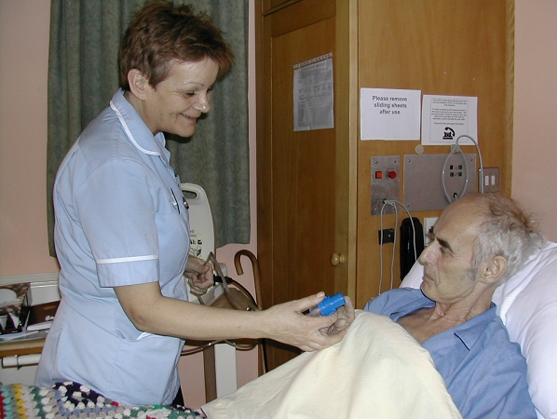
Hospices: The Christian Alternative to Euthanasia
- Founded by Christian doctors in the 1960s
- Do not practice euthanasia
- Give special care to make life as comfortable as possible for the dying person and their family (palliative care)
- Help those involved come to terms with death and sort out financial and practical worries

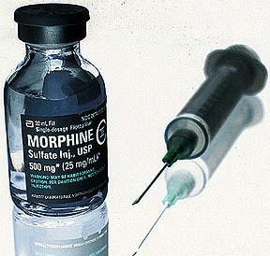
In Summary…
- Different types of euthanasia: active is illegal; passive is legal
- All Christians think actively ending a life is wrong
- RCs follow the Doctrine of Double Effect: life can be shortened as a result of pain relieving medication
- CofE: life doesn’t have to be preserved al all costs

A severely disabled newborn baby is not resuscitated when her heart fails
Non-voluntary Passive
A patient is dying and is suffering; he asks the doctor to help
Voluntary Active
An animal rights protester refuses drugs for terminal cancer
Voluntary Passive
A patient who has been in a coma for 10 years is given a lethal injection of barbiturates
Non-voluntary Active

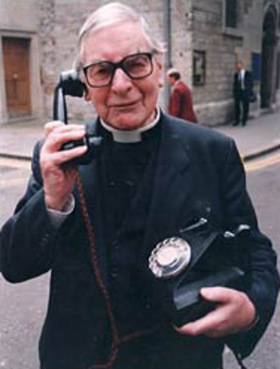
Suicide
- Before 1961, it was a crime to commit suicide; anyone who tried an failed could be imprisoned
- People who try and fail to commit suicide today, are no longer committing a criminal offence; they will usually be offered help and support with their problems
- Anyone who helps or encourages someone to commit suicide in Britain is liable to 14 years in prison
- Christians believe that life is sacred and belongs to God and so people have no right to kill themselves or others
- Christian theologians (such as Aquinas) believed that anyone who took life given to them by their Creator showed disregard for God and would be punished
- Suicide was therefore seen as a sin and people who committed suicide were thought not to achieve salvation (they were believed to go to hell)
- Today most Christians realise that suicide is the result of great unhappiness, rather than wickedness; they are more compassionate and accept that people must be under a great deal of pressure
- In 1935, Chad Varah performed the funeral of a 14-year-old girl who was buried in unconsecrated ground because she had committed suicide; she had mistaken menstruation for a serious disease and had taken her life. He vowed to help people in need and set up the Samaritans
- The organisation grew rapidly; the suicide rate fell. The global charity now takes millions of calls each year
- He said of the volunteers: ‘They are in fact people who cannot bring themselves to pass by on the other side when somebody’s needing them.’
- Christians would try to care for people and help them to live happier lives; some might volunteer for counselling services to people who are desperately unhappy


4 Christian beliefs about the use of animals in medical research
All medicines must be tested on two species of animals: one rodent and one non-rodent. Since 1986 it has been illegal to use animals if there is a possible alternative; the use of animals is tightly restricted in Britain. Scientists responsibilities include reduction: reducing the number of animals used, refinement: refining experiments to reduce animal suffering, and replacement: replacing the use of animals with alternative techniques.
The case for animal experiments is that they will produce such great benefits for humanity that it is morally acceptable to harm a few animals. The case against is that the level of suffering and the number of animals involved are so high that the benefits to humanity are not justifiable.
The Christian view:
Animals are not believed to have a ‘soul’, or to have a special relationship with God. Therefore, humans have a right to use animals for experiments, which are aimed at improving human health by testing new drugs.
Then God said, ‘Let us make man in our own image, in our likeness, and let them rule over the fish of the sea and the birds of the air, over the livestock, over all the earth, and over all the creatures that move along the ground.’ Genesis 1:26

Throughout most of Christian history, animal rights have not been considered, but as people have become aware of the issues involved, Christians have looked again at their beliefs. Many Christians agree that animals are an important part of God’s creation and that humans have duties towards animals; most Christians believe that humans should not be cruel to animals. Farmers should care for their livestock humanely and animals for food should be slaughtered without pain.
- God is the creator of all life
- God gave humans the right to control animals
- Animals do not have equal rights because only humans were made in the image of God
The Church of England View:
As human life is sacred, it is justifiable to use animals to research new drugs that can save life; God put humans in charge of the animals so they can be used for human gain.
‘The Church recognises the need for animals to be used in certain research to improve medical understanding, veterinary or behavioural knowledge, and to test the safety of chemicals, and understand that such testing is a requirement of the law. It also, however, affirms that responsible stewardship of the natural world requires all animals to receive careful and sympathetic treatment, both during their lives and in the manner of their dying.’
The Roman Catholic View:
The Roman Catholic Church agrees that animal experiments are tolerable as long as they are reasonable and the intention is to improve the quality of human health or to save lives. They also accept that animals should be used for food and clothing and they emphasise that animals should not be given exaggerated attention and care when there are humans who are suffering in the world. It is wrong to spend lots of money on expensive dog foods while ignoring people starving around the world.
Other Christians:
Some Christians do not agree with the majority of Christians and are opposed to animals being used for food, experiments, hunting and fishing. This is because:
- God is the creator of animals as well as humans
- Humans have a duty to care for animals as part of their duty as stewards of God’s creation;
- It is impossible to slaughter animals for food or experiment on them without being cruel;
- Animals have the same rights as humans.
Are not two sparrows sold for a penny? Yet not one of them will fall to the ground apart from the will of your father. Matthew 10:29
In Summary…
- Humans are God’s most important creation (made in God’s image)
- Animals should not be treated cruelly, but should be used for the benefit of humanity
- RC and CofE think experiments to benefit humans are ok
- Not all Christians agree: some Quakers think animals have equal right s to humans

