Key words:
Evil Morally wrong or bad; immoral; wicked
Moral evil Suffering caused by human behaviour
Natural evil Suffering caused by nature
Omnipotent All-powerful
Omniscient All-knowing
Benevolent All-loving
Omnipresent All-present; everywhere
Satan The accuser; the Devil; the adversary of humanity
Suffering To feel physical or emotional pain or distress
Cope To face and deal with problems or difficulties
Conscience The inner sense of what is right or wrong; impelling one to goodness
Morality A set of values that promote good conduct

Course content:
- What are meant by the terms good and evil?
- Why is suffering a problem for belief in God and how can it be explained?
- How do Christians cope with suffering?
- How do Christians know how to behave and why would they want to be good?

1 Good and Evil
Christians believe that God is good and made a perfect paradise for humans to live in. He created humans with the ability to be good, but He created them free to make their own decisions so they were more than His puppets. Evil is any cause of suffering in the world and comes from a range of sources. Humans live in a world of evil because Adam and Eve rebelled against God causing a ‘fall from grace’ where our close relationship with God was lost. Christians believe Jesus came to Earth to atone for the Original Sin and to reunite humans with God; this is refered to as the redemption of Christ.
The Devil
In Christianity, the Devil has a range of names including: Satan (The Accuser), or Lucifer (a fallen angel who tried to over-throw God in heaven, was cast out, and now roams the Earth). The Devil is the enemy of God who rules hell and causes evil in the world.
In the middle ages, the Church developed an obsession with the idea of Satan; he was often depicted as having horns, a goat's hindquarters, carrying a pitchfork, wearing red and with a forked tail. None of these images seem to be based on Biblical materials, as Satan's physical appearance is never described in the Bible. This view still has an influence today; there are Christians whose life revolves around ‘resisting Satan’. They ban music, films and games which they believe contain Satanic ideas and they hold exorcisms to rid people of Satan’s influence. Many Christians today say that whenever there is suffering in the world, or people choose to do wrong, it is because of Satan causing the tragedy or encouraging people to do the wrong thing.
The Devil works in a range of ways:
- Rules Demons: he rules a host of fallen angels (demons) who can cause physical and mental afflictions (Jesus often cured such people in exorcisms).
- Rules World: he is said to rule over governments, religions, and sciences that go against Christianity.
- Possesses: he (and his demons) are able to possess and control humans. The Catholic Church occasionally performs exorcisms, and some evangelicals do so regularly.
- Black Magic: since the Middle Ages, he has been thought to grant spells and magic powers to sorcerers and witches.
Not all Christians, however, believe that Satan is a real person. Some say that this is just a poetic way of explaining how people feel pulled in different directions, and why they often want to do things even if they know they are wrong.
Belief in Satan does not provide a perfect answer to the problem of evil: if God is all-powerful, why would he allow Satan to do anything at all? Why wait until the end of time to over-throw him; why not do it now and save people temptation and suffering?
Satan appears at various points in the Bible
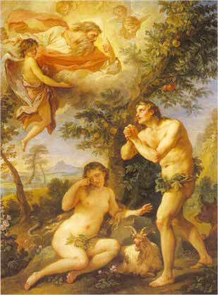 | Satan in the form of the snake tempts Eve to eat the fruit from the Tree of Knowledge of Good and Evil
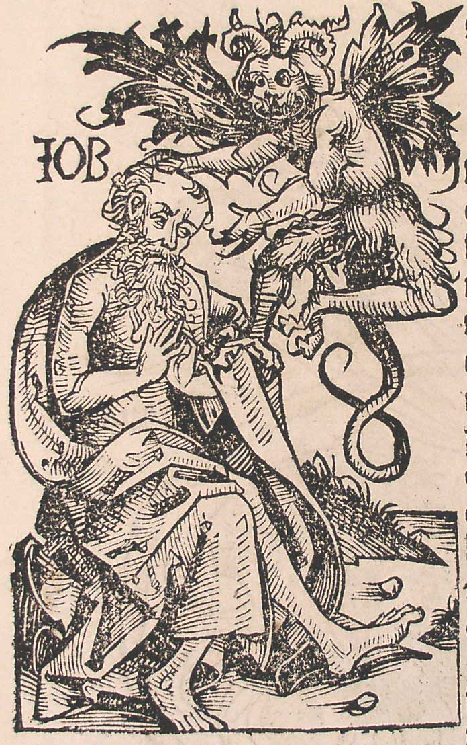 | Satan, in the book of Job, tries to make Job give up his faith by placing huge challenges his life; he has God’s permission to do this
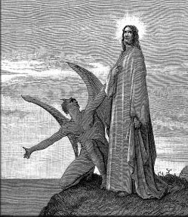 | Satan tempts Jesus to abandon God when in the wilderness for 40 days and nights. He tempts Jesus to turn stones to bread, rule kingdoms on Earth, and have protection from physical harm
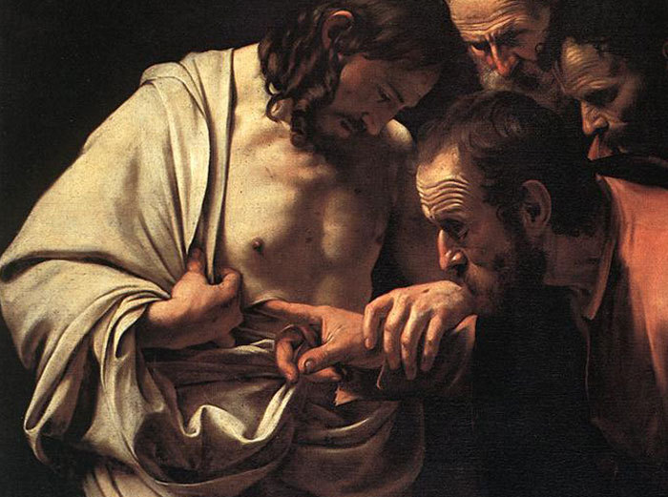 | After his resurrection Jesus warns his disciples that Satan is going to cause more trouble and that they should be on their guard
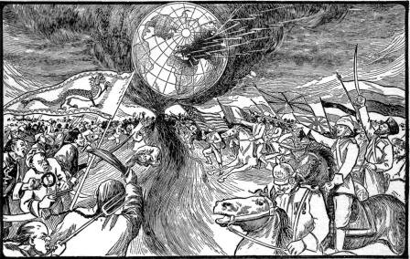 | The end of the Bible describes a final battle between God and Satan. Satan himself will be captured and cast into the lake of fire with all the wicked people. There will be ‘a new heaven and earth’, where sin will reign no more

2 The Problem of Evil including responses to and explanations of evil
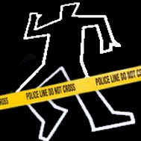

There are 2 types of evil:
Moral evil: Evil that results from human wickedness
For example: Murder, Rape, Theft

Natural evil: Evil caused by events in the natural world
For Example: Earthquakes, Volcanic eruptions, Tsunamis

If God is perfectly good, loving, and able to do anything within the world He created; then why does He allow bad things to happen? This question has always posed significant problems to Christians, and anyone with a faith in God.
Christians have to wrestle with the problem of why God appears to do nothing as people suffer. Did God make evil when He created the world? Can God be blamed for all the things that go wrong? Did something else create evil? Is God unable to prevent it? If God cannot prevent evil, then what does that say about His nature and whether He is worthy of worship?
If God is omniscient |  | Then He knows when we suffer
If God is omnipotent |  | Then He can stop us from suffering
If God is omnibenevolent |  | Then He should want to stop our suffering
God does not stop suffering in the world | 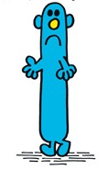 | So God is not all these things  Or  God does not exist
Christian responses to the problem of evil
Free Will:  Suffering is caused by human behaviour. If God interfered every time people did something that would cause harm to themselves or to others then people would simply be God’s puppets. God has shown people how to live – they then decide whether to follow God’s instructions and take the consequences of their actions.  (Key proponent – Irenaeus, C2nd) | We are not puppets we make our own decisions and take the consequences of our actions.  
The Story of Job:  The Bible contains many examples of humans suffering, so the Bible wrestles with this very problem. The book of Job in the Old Testament is about Job, who is a good man, who suffers total disaster. His children are killed, he loses all his property and he gets a painful and disfiguring skin disease.  The book offers three possible reasons for Job’s suffering… | - Suffering is a test  - Suffering is a punishment  - Suffering is part of God’s plan, which humans can’t understand  
We learn from suffering:  Christians sometimes argue that suffering teaches important lessons, and that we would not be good unless we were faced with difficulties.  However, can tiny babies learn from suffering? |   We could not be brave if we were never in danger
The Suffering of Jesus:  Christians believe that God cares about people when they suffer. Jesus came into the world and suffered a terrible death on the cross, so God does not ignore suffering, but shares our pain.  Sometimes, Christians say that when they suffer they feel closer to God, because they recognise their dependence on him.  The cross is at the heart of the story of Jesus, but it doesn’t tell the whole tale. Jesus came back to life after 3 days and then after 40 days went to heaven to be with God. This reminds Christians that even if this life is characterised by suffering, all this will end in heaven after death. | Suffering will end in heaven  “There will be no more death, grief, crying, pain. The old things have disappeared.” Revelation 21:4  Jesus shares our suffering  “My God, my God, why have you forsaken me?” Mark 15:34  Suffering has a purpose  “It is accomplished.” John 19:30
Christian explanations for why we can commit evil acts
Original Sin  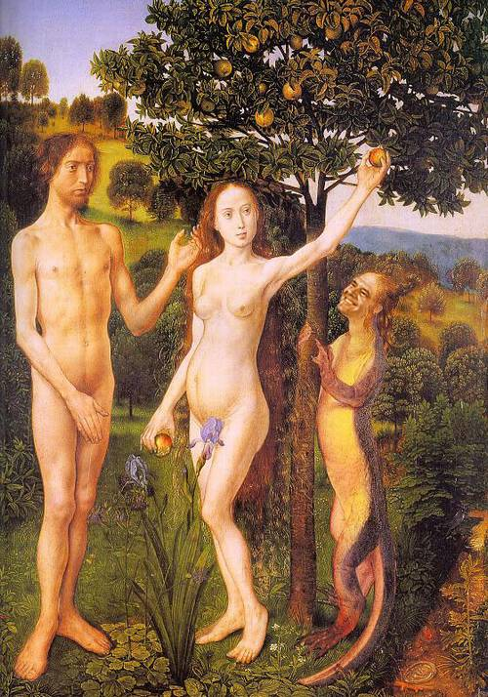  O | The Genesis story explains how we are capable of commiting sins; we were created with free will by God and we can use this to make the right or wrong decisions. Adam and Eve disobeyed God by eating from the tree of knowledge in the Garden of Eden; this introduced sin into the world. This sin caused a separation in the close relationship between God and humans and caused Adam and Eve to ‘Fall’ from grace and paradise. Since then all people have been born with a tendency towards evil in an imperfect world. Some Christians do not see the story as historically true, however all Christians see the story as explaining how suffering is brought into the world when people disobey God.
  Devil  D | The Devil is another explanation for why we can commit evil acts. Some Christians believe he is physically real and possesses people and tempts them to do evil things that cause people to suffer. Other Christians see the Devil as a poetic way of describing people making the wrong choices.
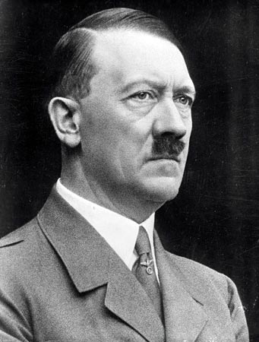  Absence of Good  A | St Augustine compared evil to human disease; he said that, just as disease was the absence of health in the same way evil is just the absence of good. When the body gets better the disease disappears, so in human experience when the good is activated the evil just disappears. Evil does not actually exist so it follows that if enough people do good, they could entirely remove evil from the world. A modern writer has put it, “All that is needed for evil to triumph is for good people to do nothing.” We have the freedom to choose how to act and so by challenging evil, suffering will stop.
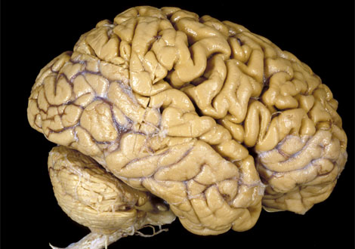  Damaged Mind  D | Some people think evil comes from people who have a damaged mind, caused by: media / experiences / parenting / schooling / diet.  All humans are capable of evil acts if their minds succumb to the effects of power and greed.
3 Coping with suffering through acceptance and prayer
What are the causes of evil according to Christians?
How helpful are these explanations of suffering?
Service | Acceptance of God’s Plan | Focus on Heaven
Learn from Your Suffering | Prayer | Focus on Example of Jesus

Focus on Example of Jesus  Christians use suffering as a way of remembering their dependence on God and to recognise that God shares in our suffering and cares for us. | Learn from Your suffering  Christians think suffering is meant to strengthen you and teach you. God will give you the power to cope, if you let him. | Acceptance of God’s Plan  God has plans, which we can’t possibly understand. Christians trust that there is some higher purpose to our suffering
Prayer  Intercession: Christians pray to ask for help for those who are suffering. | Focus on Heaven  Christians trust that everything will be clear in heaven, when all suffering will be at an end. | Service  Christians actively help those who suffer; this could include working in hospitals, hospices, or for charities
4 Sources of and reasons for moral behaviour
There are several ways in which Christians work out the right way to behave:
- Conscience
  - People instinctively know what is right and wrong because their conscience tells them
  - People feel guilty if they do wrong, even if they know that no one else will find out – this guilt comes from our conscience
  - People are influenced by their conscience – sometimes people want to do something but decide not to because their conscience prevents them
  - Christians believe that the conscience is the voice of God, guiding them
  - They believe this particularly if they pray about their moral decisions and ask God to help them
  - Non-Christians do not believe the conscience is the voice of God, they would argue that our sense of right and wrong comes from our parents and society
- The Bible
  - As the holy book of Christianity, the Bible is often used as a source of moral guidance
  - Christians study its teachings and try to apply them to their own lives and situations
  - Teachings such as the Ten Commandments are considered important by many people, whether Christian or not, to contain essential truths about right and wrong
  - Christians turn to the Bible when making difficult moral decisions as many of its teachings and stories have messages which Christians can think about, discuss in groups and try to put into practice
  - This is not always easy as the Bible was written a long time ago for a different culture. Some of its teachings are timeless and mean the same thing now as they did thousands of years ago, whereas other teachings are about outdated practices, like slavery and animal sacrifice. How can these be understood by modern Christians?
  - The Bible is an important source of guidance for all Christians: for the Church of England it is the most important source of moral guidance, however the Roman Catholic Church would look first to the authority of the Pope
- The Example of Jesus
  - Sometimes Christians try to work out the right thing to do by imagining what Jesus would do in the same circumstances
  - Because Christians believe that Jesus was God on earth they believe that he always acted and spoke in the right way
  - They try to copy him, for example they might read the Gospels about the way in which Jesus lived, look at his example and try to follow it, e.g.:
    - Jesus helped outcasts so Christians might work in a shelter for the homeless
    - Jesus said that money is not important so Christians might give to charity
    - Jesus said that violence is not the answer so Christians might be pacifists
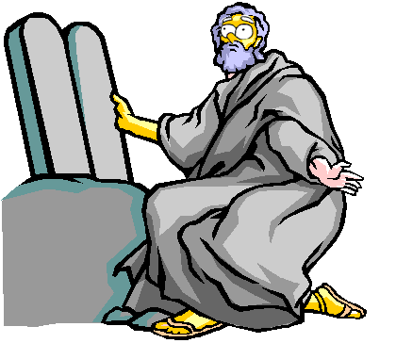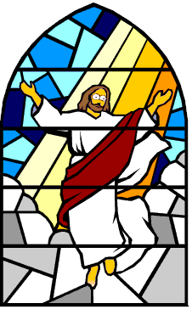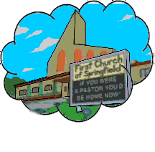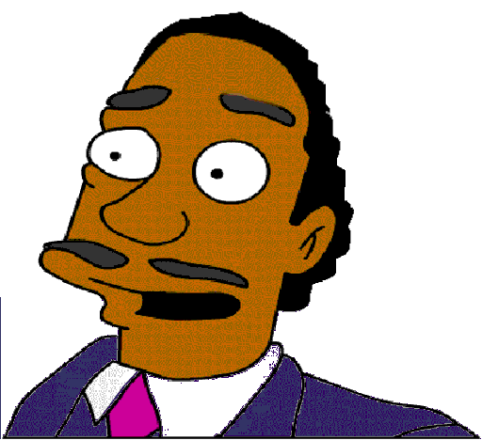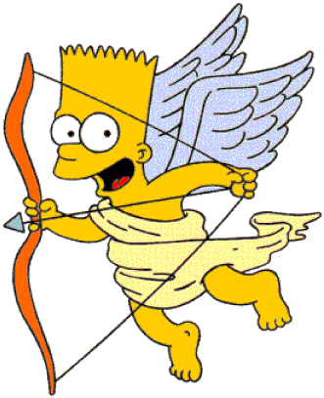
Christians are ethical monotheists; they believe in one God, who is the source of all goodness. Because humans were ‘made in the image of God’ (Genesis 1:27); they have the ability to be good in the way God has shown through the Bible and Jesus. Christians believe God is interested in the way that people behave, particularly in the way we treat each other; behaving in the right way is a way of pleasing God. We will be judged on our good and bad deeds; only those who are good will go to heaven.
- The Old Testament is full of moral teachings, explaining the right way for people to live, e.g. in the Prophets, which explain the kind of behaviour which pleases and angers God, and in rules, such as the Ten Commandments:
1 Worship one God  2 Do not worship idols  3 Do not blaspheme  4 Set aside one day of the week for prayer and worship | 5 Respect your mother and father  6 Do not kill  7 Do not commit adultery  8 Do not steal  9 Do not tell lies  10 Do not desire the possessions of another person
- The New Testament is full of Jesus’ teachings on morality. Jesus summed up the 10 commandments into 2 golden rules: Love God and love your neighbour; these are easy to apply to all situations and are the way to please God. The parables give clear moral messages (Good Samaritan: love your neighbour / Prodigal Son: forgive people). The ‘Sermon on the Mount’ (Matthew 5-7), gives clear moral advice on a huge range of issues:
  - Adultery and divorce: both wrong
  - Judgement: do not judge others, that is for God to do and you are not perfect
  - Love enemies: show love and compassion to everyone
  - Giving money and praying: don’t boast about ‘good works’
  - Wealth and possessions: these are not important and not what you will be judged on
Christians believe people who try to be good in this life will be rewarded after death – those who do good works will go to heaven, whereas those who do wrong will be punished in hell. In the past fear of hell was used to motivate people to follow a moral code; today many Christians do not believe that hell is a physical place but consider it to be a poetic way of imagining an existence without God.

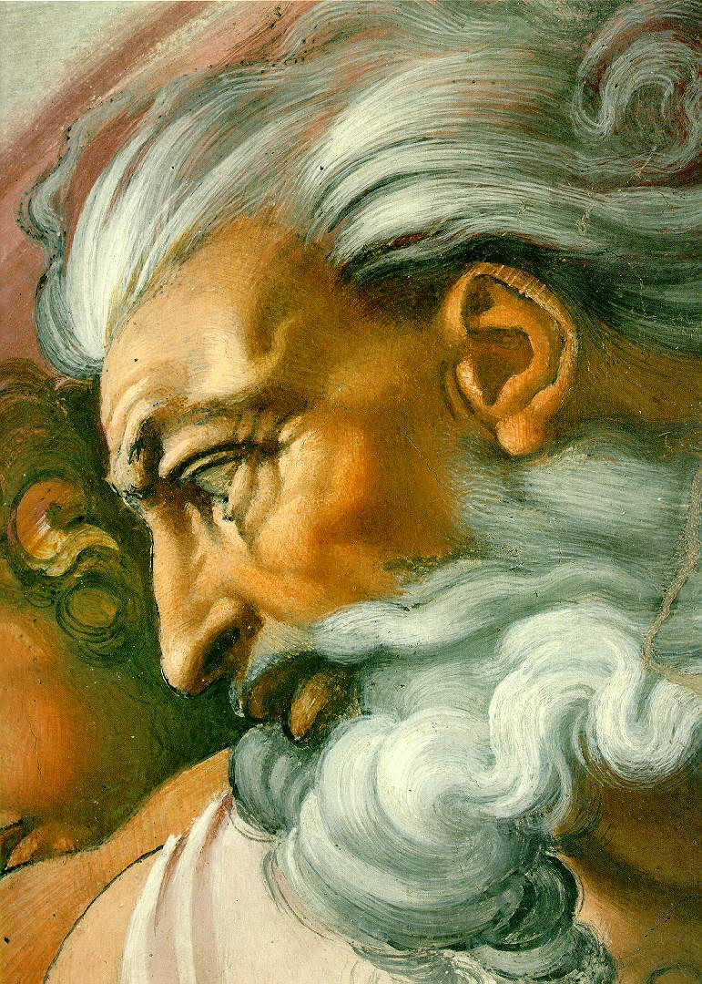
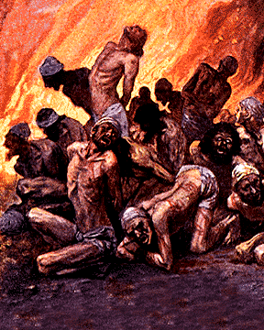
Why do Christians follow a moral code?
They believe in one God, who is the source of all goodness
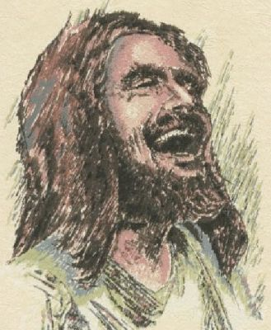
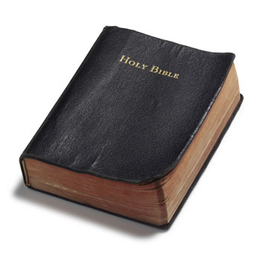
Humans are ‘made in the image of God’ so share God’s goodness
Behaving in the right way pleases God
God has given moral guidelines in the Bible (OT and NT)


They believe they will be rewarded with heaven
They believe they will avoid punishment in hell

