Key words:
Universe The entire known space and all its contents
Origins The point at which something comes into existence
Humanity All human beings collectively
Creationism Belief in the truth of religion, not scientific theory
Liberalism Belief that Science and Religion can both be right
Conservatism Belief that the Bible and scientific theories have some compatability
Big Bang A massive explosion that brought about the creation of the Universe
Evolution Theory that life develops gradually through natural processes
Dominion Rule, control, domination
Stewardship To manage the property of others on their behalf
Environmentalism Movement to protect the environment from pollution

Course content:
- What do people think about how the world and humans were created?
- What do Christians believe about the status and treatment of animals?
- What are Christian views on stewardship and the environment?

1 Ideas about the origins of the world and of humanity
Christian ideas
Before the Scientific Revolution, people thought the Earth was the centre of the Universe and everything moved around it. People believed that humans were the final part of God’s creation, and therefore the most important beings on the most important planet.
Now we know our planet is not at the centre of the Universe, we are in one of many millions of galaxies. We also know that the Universe has evolved over billions of years and is still changing, and that we are one of many life forms that is constantly evolving in response to its environment.
Science has made our position in the Universe and on Earth less central and therefore less important. The teachings of religion can still show humans to be special, being made in the image of God and having a special relationship with the Creator as shown through the incarnation of Jesus. Christian teachings about creation are found in the first book of the Bible: Genesis.
“In the beginning God created the heavens and the earth. Now the earth was formless and empty, darkness was over the surface of the deep, and the Spirit of God was hovering over the waters. And God said, ‘Let there be light,’ and there was light…” Genesis 1:1
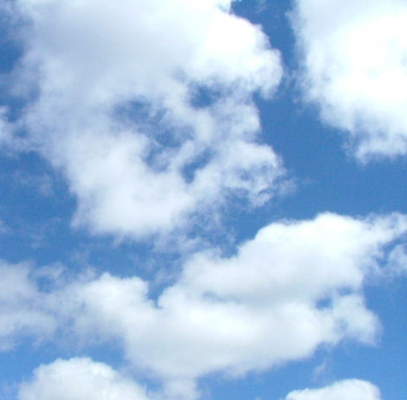
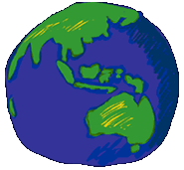




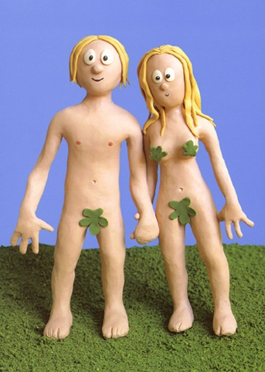
Day 1: Day and night
Day 2: Water and sky
Day 3: Sea and land; plants
Day 4: Sun, moon, and stars
Day 5: Birds and fish
Day 6: Animals and humans
Day 7: Rest
The Genesis account suggests God planned all of creation and was in charge of the process. The story of how humans were created is found in Genesis 2.
The creation of humans
God made human last; they were given pride of place in the world  LAST | 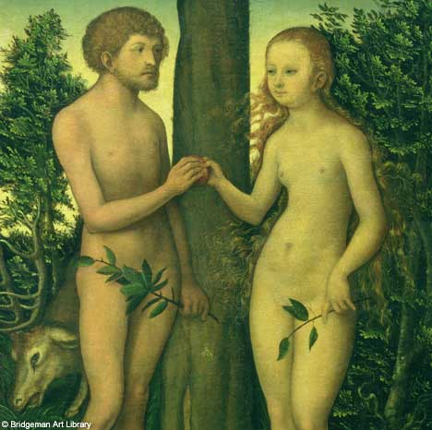 L
Humans were made in the image of God; they share something of His nature  IMAGE | 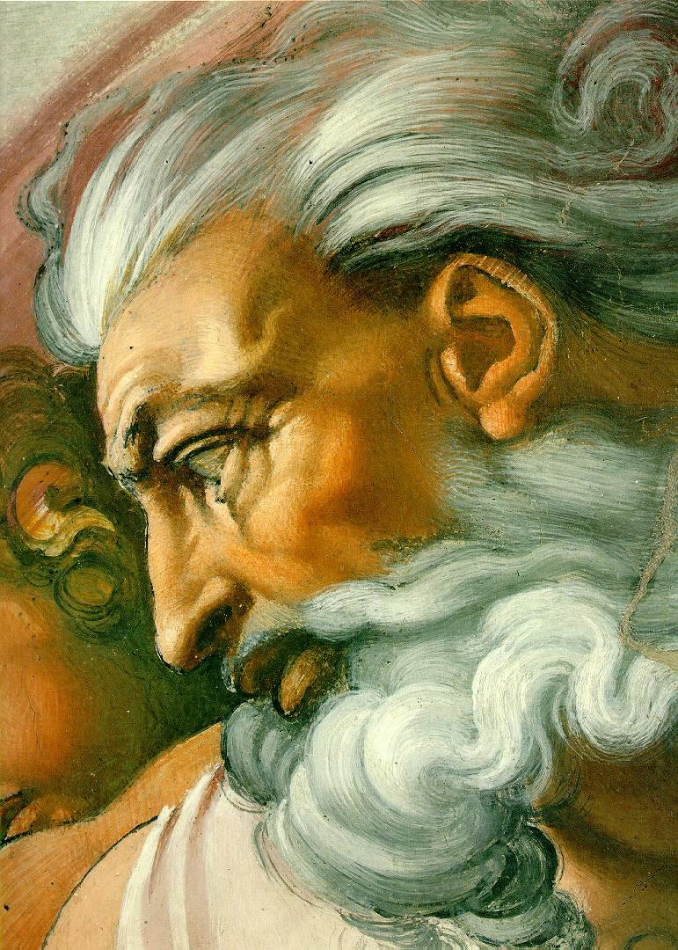 I
Adam was given the breath of life; a personal creation  BREATH | 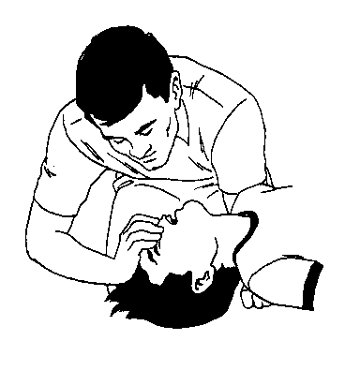 B
Humans were given a soul, animals were not  SOUL | 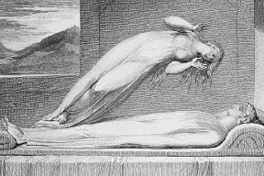 S
Adam and Eve were given the Garden of Eden to live in; it was perfect  EDEN | 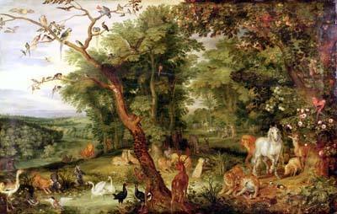 E
Adam and Eve were put in charge of all the animals and creation  CONTROL |  C
All the different animals were shown to Adam and Eve so they could choose names for them  ANIMAL NAMES | 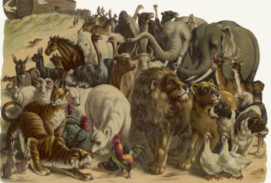 A
Importance of humans: LIBSECA
Now out of the ground the Lord God had formed every beast of the field and every bird of the heavens and brought them to the man to see what he would call them. And whatever the man called every living creature, that was its name. Genesis 2:19

Scientific ideas
Scientists think the Universe was made by a massive explosion: a BIG BANG, which sent matter and gases flying in all directions. As matter collided it formed the planets and stars that formed into galaxies; these are still moving apart as the Universe continues to expand. There is evidence to support this theory: background radiation left over from the Big Bang can be detected with powerful telescopes.

In the 19th century Charles Darwin travelled the world on a ship called The Beagle studying plant and animal life. His studies led him to conclude that species evolve over time and that they weren’t perfectly formed at one point in the past. He published his ideas in the book ‘On the Origin of Species’.
As conditions (such as climate) change, the species most able to cope will survive and reproduce; others will die out. The next generations have slightly different characteristics, which are passed on to their offspring; species gradually change over time in response to their environment.
Conditions change
Survival of the fittest
Extinction
Natural selection

The conflict
Similarities | Conflict
Similarities | Religious ideas | Scientific ideas
- The Universe had a beginning  - The Universe began with light  - Plant life came before animal life  - Humans came last and have a superior place on the planet | - Creation happened 6-7000 years ago and took 6 days to complete  - There is a plan to the Universe: God is very much in charge  - Species have all been here since the beginning of time in a perfect form  - Humans are a special creation made in God’s image, who have been given control over the animals | - The Big Bang happened 14 billion years ago and the Universe continues to evolve and change  - The Universe is here by chance and natural laws; there is no reason or plan  - Species are always changing and some become extinct if unadaptable and unsuitable to survive  - Humans have evolved gradually and have gained superiority over time; we are the product of natural forces
Responses to the conflict
Creationism | Conservatism | Liberalism
Science is wrong and religion is right: the Bible comes from God and God does not make mistakes. This view is held by fundamentalist Christians because they believe in the literal truth of the Bible. They would say that interpreting Genesis as a myth is dangerous as it can lead to interpreting other events (e.g. the resurrection) as a myth too. | There is literal truth in the Bible, but Science and religion could both be right – perhaps ‘Let there be light’ is a reference to the Big Bang? | Genesis is a creation myth using metaphorical language. It is a poetic way of describing important truths, but do not necessarily describe what happened historically. The events are not meant to be taken literally but God must have made the Big Bang and Evolution happen.
2 Christian views about what sets people apart from animals
According to Christianity, people are different from the rest of the animal world because, unlike animals, humans have souls. Christians believe the soul ensures that people, unlike animals, do not die when the body dies, but live on after death; their lives are sacred, and they have special rights and duties, which other animals do not share.
In Genesis, when God makes the other animals, they are made just as the plants are made; but when Adam is created, he is special. Humanity is made ‘in the image of God’.
So God created man in his own image, in the image of God he created him; male and female he created them. Genesis 1:27
In Genesis, people are seen to be a special creation, different from everything else in the world. It is not clear what it means to be made ‘in the image of God’; it could mean that the writers of Genesis thought that people actually looked like God, or it might mean that humans share something of the nature of God. When Adam is created, God gives him something extra, which the animals do not have, and this is symbolised as the ‘breath of life’.
Then the Lord God formed the man of dust from the ground and breathed into his nostrils the breath of life, and the man became a living creature. Genesis 2:7
In Genesis humans are given responsibility over all the other animals. Some Christians have interpreted this to mean that animals are there for people to use as it suits them and people should always put themselves and their needs first. Most Christians, however, agree that, although humans are the most intelligent species, this does not give them the right to make animals suffer unnecessarily; they have a responsibility to care for and protect animals, not to abuse them. Some Christians go so far as to say that we do not have the right to kill animals for our own purposes, for fun, for fur, or even for food.
- Why do Christians believe that people are different to animals?
Animals don’t have souls
Animals were not made in the image of God
Humans have a close and special relationship with God
- Why do Christians consider humans to have a responsibility towards animals?
God made humans ‘stewards’ of the earth
We should be responsible for their welfare and survival as we depend on them too

- How might a Christian think that animals should be treated?
Most Christians think animals should be treated kindly and with respect
Most think it is ok to use them for the good of humanity

3 Christian views about stewardship and the environment
- The very first law given to humanity was to be ‘stewards’ of the earth; stewards have a ‘care-taking role’ on behalf of someone else, so it is the job of humans to look after God’s creation on God’s behalf.
- People were put in charge of all living things, but they do not own God’s creations.
Rule over the fish of the sea and the birds of the air and over every living creature that moves on the ground. Genesis 1:28
- Some Christians think this means they can exploit the environment for their purposes.
- Most Christians think that our right to rule the planet should be balanced against our responsibilities as stewards; we are taking care of the planet for God.
The earth is the Lord’s and all that is in it. The world, and those who live in it. Psalm 24:1
- The Bible warns against greed, but rich countries still consume more than is necessary and use up the world’s natural resources faster than they can be replaced.
Life is more than food and the body more than clothing. Luke 12:22-23
The Environment
- Some Christians feel that we have the right to use the environment as we wish; we can rule over other species and put ourselves first.
- Jesus taught that people should love God; Christians would say humans should therefore love His creation and look after the environment. The Church of England and Roman Catholic Church have both issued recent statements saying Christians need to be more responsible stewards.
- Jesus taught that people should love their neighbour so Christians would try to reduce pollution and preserve resources (as well sharing them more fairly with less-developed countries).
The Parable of the Talents (Luke 19:11-26): Jesus taught that God expects humans to pass on to the next generation more than they have been given. Many Christians believe that Christians have a responsibility to leave the earth in a better state than they found it.
Love your neighbour (the principle of agape) applies to future generations as well
- Christians believe that in tackling environmental issues, human concerns cannot be ignored: shutting down a factory, which causes pollution, would not necessarily be the Christian thing to do if it would make many people redundant and poor.
What environmental issues are there today?

How can Christians be good stewards?

