Key words:
Monotheism One God
Creator God made everything in the Universe
Eternal Without beginning or end
Omnibenevolent All-loving
Omnipotent All-powerful
Omniscient All-knowing
Omnipresent Everywhere
Holy Special, separate, different
Judge Responsive to human behaviour
Holy Trinity Belief that God has 3 forms
Immanent God is in the world; close by and personal
Transcendent God is beyond the world; distant and impersonal
Bible ‘Books’; Christian Holy book
Miracle Positive event of Divine cause

Course content:
- What is God like?
- Why do Christians believe in God?
- What are miracles and how else does God act in the world?

1 Christian beliefs about the nature of God
Christians are monotheists, which means they believe in only one God. Because God is unlike anything else that exists, He is hard to describe; language about God is ordinary but God is extra-ordinary.
Why is it difficult to explain what God is like?
How do Christians think they can know what God is like?
The Doctrine of the Trinity
Christians have wondered how God can be the creator of the Universe and at the same time be interested in the lives of individual people. They have wondered how He can be both transcendent (beyond the world) and yet immanent (within the world) at the same time. They have wondered how He can be close by and personal, but also impersonal and entirely separate from human nature.
One of the ways Christians try to address these issues and express their understanding of what God is like is through the doctrine of the Trinity. God is understood in three different ways: the Father, the Son, and the Holy Spirit; this does not mean that there are three gods as Christians are monotheists, but it does explain how God can be omnipresent, but also understanding of us as individuals with ever-changing problems.
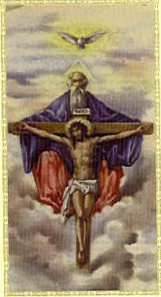
The Holy Spirit: immanent yet impersonal (unlike a human); ‘God around us’ who inspires and guides Christians from day to day.
(gives courage / comforts / guides / oversees, like dove)
The Father: transcendent and impersonal (unlike a human); ‘God beyond us’ who created the world and keeps it going.
(distant / close / loving / protective)
The Son: Jesus, immanent and personal (human-like); ‘God beside us’ who came to earth and lived a human life.
(teach / sacrifice / atone / resurrection)

The idea of the Trinity is supported in the Bible through the account of Jesus’ baptism:

“… Jesus came from Nazareth in the province of Galilee, and was baptised by John in the Jordan. As soon as Jesus came up out of the water, he saw the heaven opening and the spirit coming down on him like a dove. And a voice came from heaven, ‘You are my own dear son. I am pleased with you.” Mark 1:9-11
Note for your exam:
If you are asked to describe what Christians believe God is like; you must talk about the TRINITY and explain it clearly. You should aim to include a range of the key words and define them; don’t assume the examiner knows what they mean as you are not displaying your knowledge and, as they don’t know you, they won’t give you the benefit of the doubt!
JOBITTEM
God in summary:
Beliefs Monotheism / Trinity
Jobs Creator / Judge / Father
Nature Eternal / omnipresent / omniscient / omnipotent / benevolent / transcendent & immanent: TRINITY
2 Reasons Christians give in support of their belief in God
There are many reasons why someone might believe in God whether through logical argument or through personal experience.
Fill in the missing words from the word bank below:
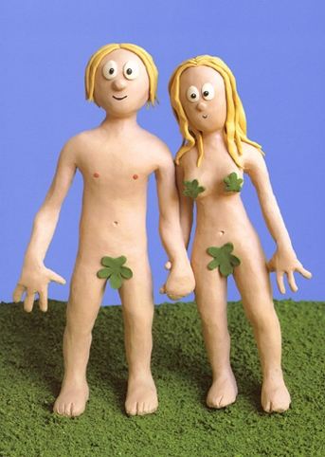
The Cosmological Argument, proposed by St Thomas Aquinas aims to prove God’s existence through the observation of cause and effect. Every effect that we see happening in the world must have been caused by something else. At some point in the past, there must have been a first cause of everything. This first cause must be eternal (without beginning or end) because otherwise the first cause would need a cause. This first cause must be God. However, some people suggest that the universe itself could be eternal or that there is no reason why the first cause has to be God; it could have started with the Big Bang.

In the Teleological Argument, William Paley aimed to prove the existence of God from the starting point of design in the world. He used the analogy of a watch discovered in a desert to argue that God exists. Just as looking at the watch makes you assume the existence of a watch-maker looking at the world makes you assume the existence of a designer, and this must be God. The theory of evolution discovered by Charles Darwin challenges this theory.
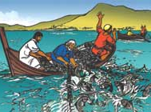
Many people have pointed to the fact that sometimes things happen, which cannot be easily explained; they suggest that the existence of God could help to explain them. They include physical things that happen, which we might call miracles, and experiences in which people claim to have encountered God, perhaps through a feeling of awe and wonder. However, believing in a miracle or religious experience is often a matter of faith; these are less likely to convince other people.
St Anselm’s Ontological Argument uses language to explain the existence of God. Put simply, he suggests that if God is the greatest being we can possibly imagine He must exist because God in existence is greater than God in imagination.
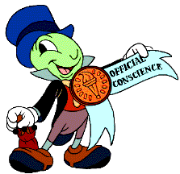
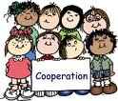
Some people use human morality as an argument for God existing. They suggest that humans are born with an inbuilt sense of right and wrong and this must have been programmed into us by God who is the source of moral knowledge. The fact that we feel guilt when we do the wrong thing also suggests there is a moral authority to which we are responsible: if there was no God to answer to then we wouldn’t feel shame or guilt. Some people say that if there is no God and no afterlife then there is no motivation to do good works in this life so the fact that people are kind towards others must come from duty to God. Other people argue that we learn what is right and wrong through experience and the need to co-operate in a society, therefore this argument does not prove God’s existence.
Some Christians base their belief in God on their upbringing; because their family believe in God they may have never questioned God’s existence. They will have been brought up to pray and visit Church regularly and questions about the world will have been answered with reference to God as creator, father and judge. This is personal and would not help to convince others that God exists.
Miracles eternal God prove watch language God
explained guilt design cause learn miracle evolution
St Anselm’s caused first world God explain family
watch-maker awe faith Darwin first eternal wrong
shame Church St Thomas Aquinas
E People can experience God in a range of ways such as answered prayers, healings, miracles, dreams and visions; it could also be a strong sense of God’s presence.
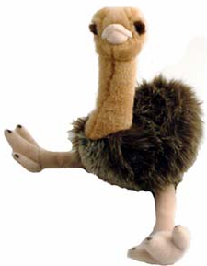
This is the argument from experience
M Our conscience give us a sense of right and wrong and makes us feel guilty, even for things that are secret; there must be a source of this knowledge.
This is called the Moral Argument

U Some people are brought up as Christians from an early age and their faith has always been strong because of this; this is unlikely to convince other people
C The Universe cannot just have come into existence by itself; there must have been a first cause (creator) who started it all off.
This is called the Cosmological Argument for the existence of God
O God is the greatest being that can possibly be imagined; existence must be part of His greatness
This is called the Ontological Argument for the existence of God
T There are many examples of things in nature that appear to have been designed for a purpose; there must have been a designer who planned it all out.
This is called the Teleological Argument for the existence of God

3 The concept of miracles and how God acts in the world through miracles / Jesus / Holy Spirit
Christians believe that God did not just start the world off and then go away; He has had a relationship with humanity ever since the first people were created, and this relationship continues today. God can act in the world because he is omnipotent and benevolent; people can experience Him in a range of ways because of His nature explained through the Trinity.
Many Christians believe that God acts in the world through miracles; these events show God’s omnipotence and benevolence. Thomas Aquinas suggested that miracles could be put into three different categories:
A violation of the laws of nature |  | 
A natural process speeded up or slowed down |  | 
A normal event that is perfectly timed |  | 
Jesus performed many different types of miracles during his time on Earth and these are recorded in many accounts in the Bible. Miracles still happen today through the power of the Holy Spirit acting within the world. They can happen through prayer and sometimes through visiting special places where visions have occurred such as at Lourdes in France.

Jesus’ miracles:  Nature:  Healing:  Exorcism:  Resurrection: | 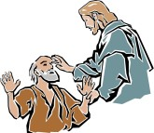    
Some people believe that they have been miraculously healed, even from seemingly incurable illnesses (Jean Pierre Bely was ‘cured’ of MS in Lourdes). Others believe that they have been saved in times of danger or that they have been sent a special sign from God.
The person of Christ:
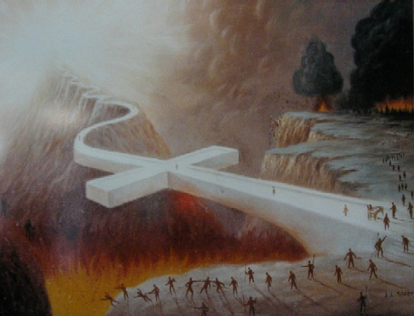
- Most important way God showed his involvement in the world is through the incarnation of Jesus where God was truly immanent
- Christians say we do not have to wonder what God is like because He came into the world and showed us
- Jesus shows God cares enough about people to want to guide them back to God through his teachings and sacrifiice to atone for the sins of humans
Explain what Chrisitans mean when they refer to Jesus as saviour. Use the picture above to help.
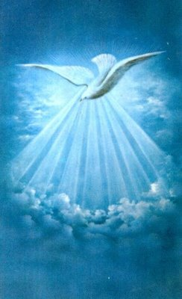
The Holy Spirit:
The Holy Spirit guided the disciples to help establish the early Church. The Holy Spirit is immanent and offers comfort, guidance, faith, hope, understanding and spiritual strength to people. It also gives gifts of inspiration to help people and is the source for miraculous events on Earth today (such as those at Lourdes); some people say they have been filled with the presence of the Holy Spirit and have been able to do unusual things, such as talking in tongues.

