Cover Wednesdays: 23rd March 2011

The below questions are homework. You have this lesson to make a start on them. Any you don’t finish will need to be done for Tuesday 29th March. Work hard!

1. Quadratic Equations:

Solve the following quadratic equations by using factorisation:

(a). 2x² – 5x – 3 = 0 (b). 6x² + 5x – 6 = 0 (c). x² + 6x + 9 = 0

Solve the following quadratic equations by using the formula:

(d). x² + 2x + 1 = 0 (e). 2x² + 4 – 3 = 0 (f). 5x² + x - 4 = 0

2. Simultaneous Equations:

Solve the following simultaneous equations:

(a). x² + y² = 34 (1) (b). a + b + c = 5 (1)
2x – 1 = y (2) 2a – b – c = 7 (2)
a + 2b + 3c = 8 (3)

3. Density:

(a). An object has a mass of 800g and a volume of 240cm³. What is its density in kg/m³?

(b) A cone of density 2,300kg/m³ has a height of 10cm and a base radius of 4cm. What is its mass?

(c). A sphere of radius 5cm has a mass of 500g. Given that the density of water is 1,000kg/m³ will my object float or not? How much would an object of the same size need to weigh to change this?

4. Distance, speed and time:

(a). A plane travels at 240m/s for 3 hours. How far does it travel in this time?

(b) A man is walking at 1.8m/s towards a town which is 3.8km away. How long will it take (in hours)?

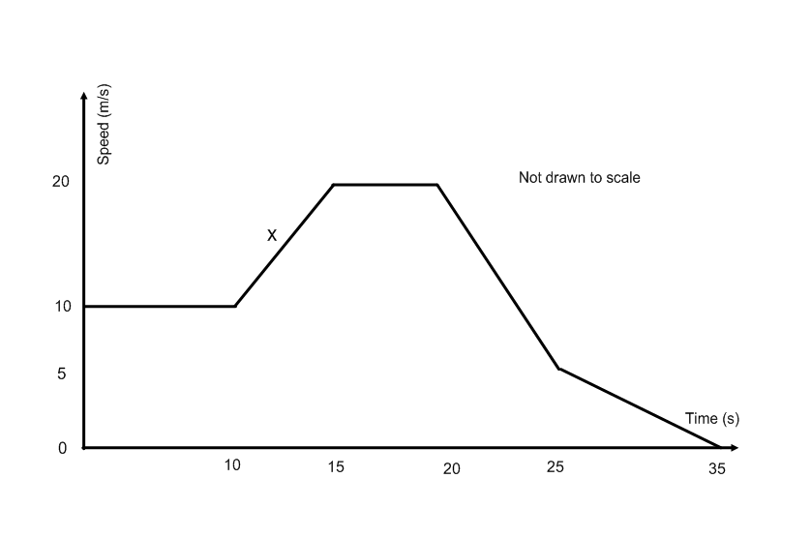
(c). “A lady driving a car accelerates quickly and is soon cruising at a consistent speed. A cyclist pulls out in front of her so she breaks hard and comes to a halt. After this she begins to accelerate again, but more slowly and come to a slower steady speed than she did before.” Draw a speed-time graph to represent this story (using a ruler).

(d). Use the graph to the right to work out:
(i) the total distance travelled
(ii) the acceleration at point “x”

